Open Geomatics Community of Practice

Chris Mulverhill (Professor) Sarah Smith-Tripp (Teaching Assistant)

2024-07-31

Table of contents

# 1. FRST 556: Land Information Acquisition and Analysis

# Welcome

These are the course materials for FRST 556 - Land Information Acquisition and Analysis. A course taught as part of the Masters in Forest Resources Management (MSFM) in the Faculty of Forestry at UBC. This course covers critical elements for accreditation by the Association of British Columbia Forest Professionals (ABCFP) and by the Society of American Foresters (SAF). The **9 exercises** of this course cover key knowledge concepts including:

* Basic Level GIS
* Plot and Stand Level Statistics
* Working with Forest Inventory
* Projecting forest inventory using TIPSY and VDYP
* Developing management plans

This web-page hosts lab assignments that students enrolled in FRST 556 must complete for credit. **Note that much of the data referenced are either public datasets or otherwise only available to students enrolled in the course for credit**. Deliverables for these assignments are submitted through the UBC learning management system and only students enrolled in the course may submit these assignments for credit.

## How to use these resources

Each “module” is a standalone lab exercise designed to be completed over one or two weeks.

Students enrolled in FRST 556 will submit all deliverables through via the UBC course management system (canvas). Deadlines and submission locations can be found on canvas. The casual user can still complete the tutorials step-by-step, but not all data are publicly available nor are hosted on this website. Therefore a casual user may have issues completing all modules.

Unless otherwise noted, all materials are Open Educational Resources (OER) and licensed under a Creative Commons license (CC-BY-SA-4.0). Feel free to share and adapt, just be sure to share with the same license and give credit to the author.

## How to get involved

Because this is an open project, we highly encourage contributions from the community. The content is hosted on our [GitHub repository](https://github.com/ubc-geomatics-community-of-practice/GEM511-Advanced-GIS-for-Environmental-Management) and from there you can [open an issue or start a discussion](https://github.com/ubc-geomatics-community-of-practice/GEM511-Advanced-GIS-for-Environmental-Management/issues/new). Feel free to open an issue for any typos, factual discrepancies, bugs, or topics you want to see. We are always looking for great Canadian case studies to share! You can also fork our GitHub repository to explore the source code and take the content offline.

# 2. Introduction to Forestry Datasets in QGIS

Written by

Sarah Smith-Tripp

## Lab Overview

Foresters use maps to visualize site composition, leading tree species, and volume across a landbase. In this lab, we introduce the datasets enable forestry professionals to create these maps. The focus of the lab is not on the GIS approach, but rather becoming familiar enough with the data structure you feel empowered to create your own maps for a landbase. We will also do some simple calculations within QGIS to better understand the data structure and possible applications. This lab uses forest inventory data from Malcom Knapp Research Forest (MKRF)

## Learning Objectives

* Import & understand spatial data sets from MKRF
* Create a map that visualizes site indices
* Create a map for leading tree species and include descriptive statistics (area covered, XX YY)
* Calculate a volume estimates for western red-cedar in 1989
* Compare calculated values for 1989 to estimates for 1999 and discuss the changes

## Data

We will be working with GIS data available from Malcom Knapp Research forest. Description of data is included in Section 10.1. ## Background {.unnumbered}

Malcom Knapp Research Forest is a UBC affiliated research forest that is located near Maple Ridge, BC. The forest was established in 1949 and is managed by staff to be *commercially viable* and *financially independent* of UBC. The forest is ~5,000 ha and covers a large mountainous area. Most of the forest is located in the Coastal Western Hemlock (CWH) biogeoclimatic (BEC) zone. As a result, some of the trees are very large (> 2 m than diameter and over 65 m).

## Task 1: Set Up QGIS

**Step 1:** Open QGIS on your laptop. Choose ‘blank project.’ Save the project with a file name that you can remember and location you can remember. Ex: Exercise1_Map.qgz

When you first open QGIS you will notice a main map canvas. To the left of this map canvas are two windows **Browser** and **Layers**. The **Layers** panel is the best way to understand the order of data on the main map canvas and is the best way to change the data presentation (symbology) and access the data in tabular format. On the top the QGIS menu are a series of additional buttons which we will introduce throughout this lab and course. Finally, on the bottom are the details of the map canvas including the current center or selected coordinate, the map scale, rotation, and the coordinate reference system (CRS)

**Step 2:** Set the project CRS. In BC, the provincial standard CRS is NAD83/BC Albers map projection (EPSG:3005). To set the projects CRS navigate to the bottom left of the window and click on the **EPSG:4326 as shown below:**

Search for EPSG:3005 and **click apply** and **Ok**.

**Step 3:** Set up a ‘favorites’ folder to easily access the MKRF data. Right click on ‘Favorites’ and click **add a directory**. Navigate to the storage location for you MKRF data. Click **ok**

#### Building Familiarity

**Step 4:** Add **P_Boundary_MKRF.gpkg** to the map. From the **browser** window select the file and **drag and drop** into the main map. This will add the boundary MRKF as a polygon feature. This layer is shown in the main map and listed in ‘layers’ on the left-hand ‘layers’ panel.

**Step 5:** Change the symbology of the boundary file by right clicking on **P_Boundary_MKRF.gpkg** in the layers pane. Select **Properties**. A window will pop-up. On the left-hand side the layer properties including: General, Source, Symbology, Labels, Fields, Joins, Diagrams. Select **Symbology** (The icon with the paintbrush). Keep the format as ‘single symbol.’ Change the layer to have a black outline with no fill by clicking on the icon ‘simple fill.’ Change the fill color to ‘transparent’ and the stroke width to ‘0.2’

**Step 6:** Add **L_streams_major.gkpg**. In the ‘layers’ panel this will be the first, reflecting that this layer is above the boundary file. Change the color to something that represents streams (like.. blue?)

**Step 7:** Navigate the around the map project by selecting the  icon. You can use the  to zoom and out.

**Step 8:** Add the **P_lakes.gpgk**. Right-click on this layer in the layers panel and select **Attribute Table**. This gives details about the polygon features of the dataset. The shape area for each has been calculated in the ‘Shape_Area’ field.

### Question 1:

How many features (i.e. shapes) are in the P_lakes.gpkg?

### Question 2:

Where are the high versus low site indices relative to the terrain, relative to the north versus south, and relative to roads?

## Task 2: Making a Site Index Map

Site index is a measure of productivity. It is technically defined as: *expected height (m) of the best trees (not damaged, biggest) of the dominant species at a reference age of 50 years breast height age*. The site index reflects the potential of the site to grow this dominant species. Although this might also indicate how another species might do, this does not give a measure of the possible productivity of another species. For example, a site that is douglas-fir leading and has a high site index would not indicate that a species like whitebark pine (a high alpine species) would also do well. Also, if the soils change (e.g., landslides, fertilization, etc.) or the climate/hydrology changes, the site index might not be a good an indicator of the productivity for the historically dominant species. Importantly, for site index to be reported there have to be trees in the stand. In the MKRF dataset some recently harvested stands may show a “0” for site index, but this is really an NA.

**Step 1** Load **P_ForestCover_1989.gpkg**. Right click on the layer in the **layers** window and select **Open Attribute Table**. this will open an attribute table that describes the polygon components. Click on the the heading for **SITEINDX** to sort the table from smallest to largest site index. Many polygons have “0.0 m” for a site index value. Scroll right to the “non-forest descriptor” or **NFD** columbn. Here notes like “NSR” note sites that are “not-satisfactorily restocked, or there may be lakes. These are examples of polygons where there are no trees and thus no site-index value.

**Step 2** Click to the **SITEINDX** column heading again to sort from largest to smallest. See **?@sec-Q3** to answer. Close the attribute table.

**Step 3** Right click on the **P_ForestCover_1989** layer again in the **layers** panel and select **Properties**

1. Select **Symbology** and change the symbol from “single Symbol” to “Graduated”
2. Under **Value** click the small down arrow on the right to select the “SITEINDX” column.
3. In the **Color ramp** field click the small down arrow on the right to select the “Viridis” color palette
4. At the bottom of the symbology window, select **Classify**. This will classify the values in “SITEINDX” based on their values into different colors associated with the viridis color ramp.
5. Under **Classify** and **Mode** select “Equal Interval” and change the number of **classes** to “12”. Click **Classify** again.
6. In the **Classes** pain (the main white box) change these to **5 m classes** as 0.00 to 0.00 (i.e., no site index), 0.05 to 5.05, 5.05 to 10.05, 10.05 to 15.05, etc.
7. Click **Apply and OK**. The symbology window will close and you can now see your recolored layer

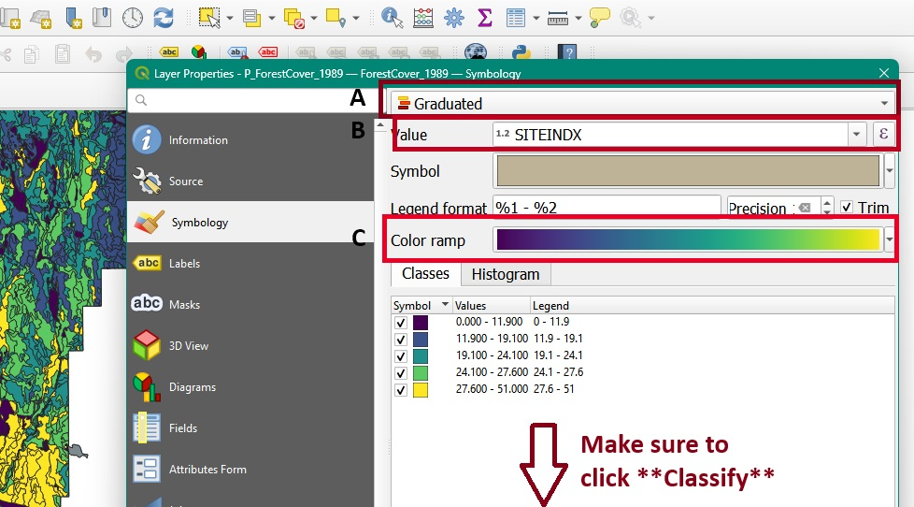

**Step 4** Create a site index map to export as a picture. ::: {#tip-mapmaking .callout-tip} check out this link for some useful resources on making maps in QGIS :::

1. Select **Project** -> **New Print out** **Layout**. Name your print layout “MRKF_1989SiteIndex” and click **OK.** A blank space appears in a new window with new Layout icons along the left-hand side.
2. In the left-hand of this new window, select  to (**Add a New Map to the Layout)**. A **+** sign appears as a cursor. Drag the cursor around the blank area. Your map appears in this print layout.  **NOTE:** If you do not see a map in **Layout View** use **Zoom Whole Page** =You may also need to reposition the map in the copied box using:

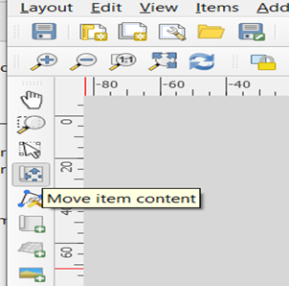

1. In the left-hand of this new window, select  to (**Add a New Map to the Layout)**. A **+** sign appears as a cursor. Drag the cursor around the blank area. Your map appears in this print layout.  **NOTE:** If you do not see a map in **Layout View** use **Zoom Whole Page** =You may also need to reposition the map in the copied box using:
2. **Right click** on your map and select **Page Properties**. Change the orientation from “landscape” to “portrait”.
3. **Right click** on the map again and select **Item Properties** this time. Change the map scale (see the right-hand side of your screen for the properties) to expand your map to fill the page.  A good scale value is 50000 which means 1 cm on the map represents 0.5 km (50,000 cm)
4. Use  on the left-hand side to add a **Legend** (the + sign appears in the cursor, drag the cursor and Legend appears).
5. Use  to add a **Scale Bar.** Click on the **Item Properties** box. Change the “Division Units” to kilometres and then select a scale graphic you like.
6. Use  to add a **Title**.
7. Add a north arrow by clicking  and drag the curse to the map area.
8. Right click on each item on your map and select **Item Properties** to make any other changes to improve the appearance of your map. Alternatively, on the right-hand side there is **Item properties** icon where you can change the style of the items you added to the map (i.e., north arrow, legend, your map). NOTE: One could spend many hours on this! Just do some improvements.

**Step 5** Export your map as an image. Go to **Layout** and select **Export as Image.** Save the image the same location as your document you are recording lab responses.

### Question 3:

What was the largest site index in m? What was the leading or dominant species for that polygon? Give the full name and the Latin name for the species.

### Question 4:

Add 5 m contours onto your map canvas. Where are the high versus low site indices relative to the terrain, relative to the north versus south, and relative to roads?

### Map 1

Include your Site Index Map with a proper title, legend, scale, and arrow bar.

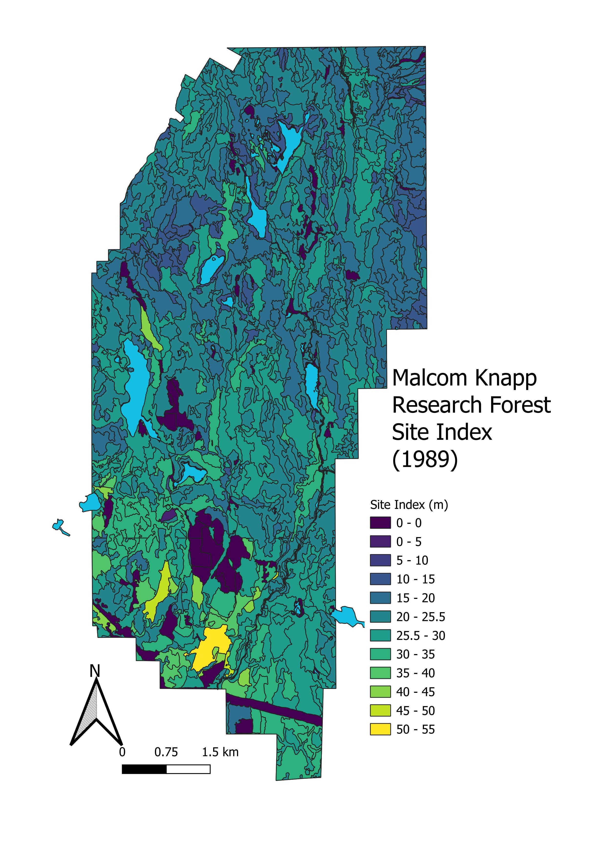

## Task 3: Visualize Stands Dominated by Western Redcedar in 1989

**Step 1** Close the **Layout** window and go back to the **Data view** window again.

**Step 2** Change the **fc_1989**-layer properties to a **Single Symbol** again.

**Step 3** Right click on the **fc_1989** layer and choose **Open Attribute Table**. Each line of this table shows the attributes for one polygon (including **SITEINDX** that you already used). You can see the total number of polygons at the top of the **Attribute Table** (1149 polygons). Keep this attribute table open in this new window.

**Step 4** Select polygons where the first species is western redcedar and the cedar is more than 50% of the species composition. To do so you will use a “Query.” To select polygons where the first species is western redcedar and more than 50% of the species composition, you will need to do a Query.

1. In the **Attribute Table** select  to open up the **Query Fields**
2. Scroll down a bit to find “SPSC1” and “PCT1”, select for **SPSC1**=C and **PCT1**>=50. Click **Select Features**

* 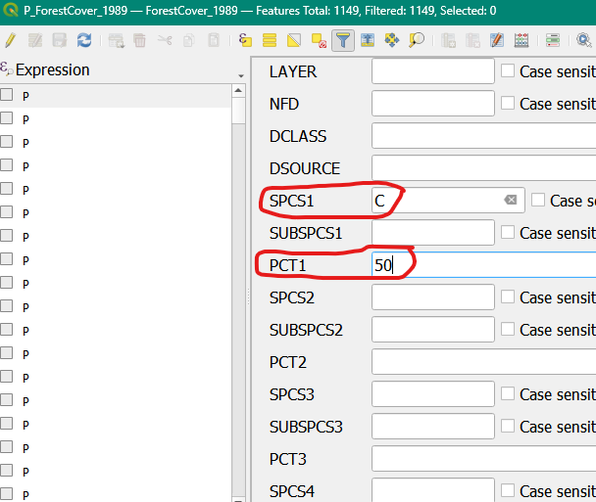

1. Click the  to return to the tabular format. You can see that we have now selected have a SPCS1 (leading species) of “C” for cedar, and that these polygons are >= 50%. Use this to answer **question 5**

**Step 6** Export your selection under it’s own shapefile. You can minimize or close the attribute table. In the **layers** panel right click and select **Export -> Save Selected Features As** save this as a gpkg file in the same folder as your MRKF data. Name this **P_FC_1989_CedarLeading.gpkg**.

**Step 7** Calculate the area and volume of cedar dominant stands in 1989.

1. Click on the **vector** icon in the top menu and go to **Analysis Tools -> Basic Statistics for Fields**
2. In the pop-up window select your P_FC_1989_CedarLeading shapefile. In the **field to calculate statistics on** click the downward arrow and select “Shape_Area.” Since this is a simple calculation, we will run this as a “temporary output.” Therefore, click **Run** on the bottom right.

C. In the window that appears, find the **count, mean, and sum values**. Use these to answer **?@sec-Q7** and question 8.

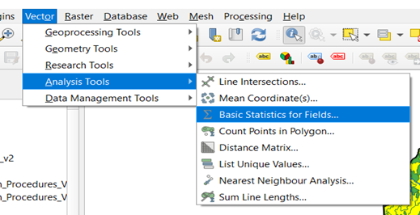

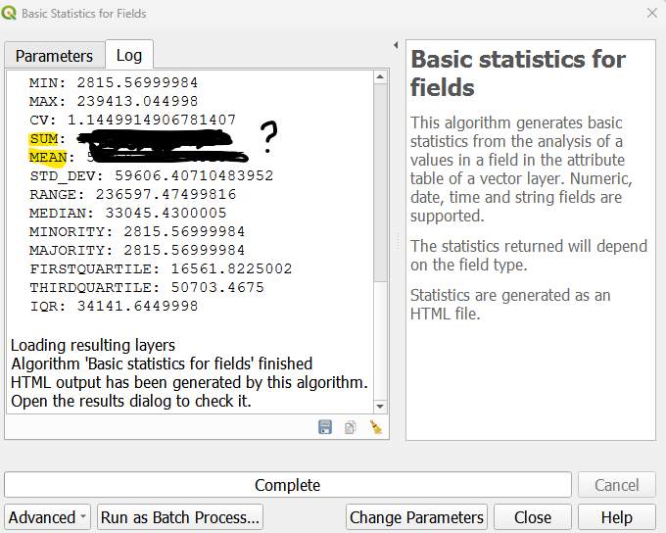

**Step 9** Calculate the merchantable volume in the 1989 cedar dominant stands.

1. Right click on the P_FC_1989_Cedarleading layer. Find the **Field Calculator**  tool.
2. In the pop-up window make sure **Create a new field** is checked. Input a formula to calculate shape area on. To calculate volume for the polygon, we need to use a measure of volume for the area. We have **VOL7_5** which is the volume of trees per hectare that are > 7.5 cm. We also have **Shape_Area** which is the area of the shape in m². We can use the following formula to calculate the volume per polygon

$$Total Volume\left(m³\right)=Polygon Area\left(XX\right)*Volume\left(m³/ha\right) \left(2.1\right)$$

1. Do a unit calculation to set up the equation. Shape_area is in m² and VOL7_5 is in m³/ha. If we want output to be in m³ what value do we need for XX ?
2. Name the field “m3_volume.” Change the **Output field type** to “Decimal number (real)” and click **ok.** Estimates for volume for each polygon will now appear. Use these outputs to answer **?@sec-Q9**.
3. Use the **Calculate basic statistics tool** to calculate the average and total merchantable volumes in the cedar leading polygons.

**Step 8** Make a map of the polygons dominated by western redcedar. Look back towards @tip-mapmaking to remind yourself of the process and the essential components to include in your map.

### Question 5:

1. How many western redcedar (>= 50%) polygons were there in 1989?
2. Where are they located?
3. What polygons are not selected with the filter applied to the data?

### Question 6:

What is the FULL latin name for western redcedar (including the namer - a reference to the person that named the species)?

### Question 7:

What is the average polygon size (ha) for the western redcedar dominated stands in 1989? NOTE: 10,000 m2=1 ha (i.e., 1 ha is 100m X 100 m = 10,000 m2)

### Question 8:

What is the total area in ha of all these selected polygons combined?

### Question 9:

What is the value of XX in Equation 2.1 above? Using this equation, hat is the merchantable m3 volume (i.e., merchantable volume for trees 7.50 DBH or larger) for all these selected polygons combined? Do you feel like this a lot? (for reference a utility pole is 1m^^3)

### Map 2:

Include your map describing historically dominant cedar stands with a proper title, legend, scale, and arrow bar.

## Task 4: Compare Changes in Western Redcedar from 1999 to 1989

Whew - you made it through the first interaction with QGIS in this course. Congrats 🎉. Your instructors used the same steps that you used for 989 to map and to get some statistics for western redcedar dominated stands, but this time for 1999.  There were 1,220 polygons in 1999 and 170 were dominated by western redcedar (Figure 1). The average polygon size for these stands was 3.90 ha with a total number of ha of 662.53 ha.  The merchantable volume for all of these stands combined was 319,903.0 m3.

### Question 10:

Which year (1999 or 1989) had a large polygon size for western red-cedar dominated stands? Please answer in hectares.

### Question 11:

Did the m3 for all these selected polygons combined increase or decrease from 1989 to 1999?

### Question 12:

Based on your knowledge of forest dynamics so far, what might have caused these differences area and volume of western redcedar dominated stands between 1989 and 1999? HINT: Think about what human (e.g., new roads, harvests, silvicultural treatments, etc.) and natural (e.g., fires, landslides, etc.) disturbances may have occurred for MKRF in the CWH BEC zone in particular

## Lab Questions & Deliverables

* ☐ Complete answers to the following questions:
  + ☐ Question 1: How many features (i.e. shapes) are in the P_lakes.gpkg
  + ☐ Question 2: Where are the high versus low site indices relative to the terrain, relative to the north versus south and relative to roads?
  + ☐ Question 3: What was the largest site index in m? What was the leading or dominant species for that polygon? Give the full name and the Latin name for the species.
  + ☐ Question 4: Where are the high versus low site indices relative to the terrain, relative to the north versus south, and relative to roads?
  + ☐ Question 5: (a) How many western redcedar (>= 50%) polygons were there in 1989? (b) Where are they located? (c) What polygons are not selected with the filter applied to the data?
  + ☐ Question 6: What is the FULL latin name for western redcedar (including the namer - a reference to the person that named the species)?
  + ☐ Question 7: What is the average polygon size (ha) for the western redcedar dominated stands in 1989? NOTE: 10,000 m2=1 ha (i.e., 1 ha is 100m X 100 m = 10,000 m2)
  + ☐ Question 8: What is the total area in ha of all these selected polygons combined?
  + ☐ Question 9: What is the merchantable m3 volume (i.e., merchantable volume for trees 7.50 DBH or larger) for all these selected polygons combined? Do you feel like this a lot? (for reference a utility pole is 1m^^3)
  + ☐ Question 10: Which year (1999 or 1989) had a large polygon size for western red-cedar dominated stands? Please answer in hectares.
  + ☐ Question 11: Did the m3 for all these selected polygons combined increase or decrease from 1989 to 1999
  + ☐ Question 12. Based on your knowledge of forest dynamics so far, what might have caused these differences area and volume of western redcedar dominated stands between 1989 and 1999? HINT: Think about what human (e.g., new roads, harvests, silvicultural treatments, etc.) and natural (e.g., fires, landslides, etc.) disturbances may have occurred for MKRF in the CWH BEC zone in particular
* ☐ Complete Maps for :
  + ☐ A site index map for Malcom Knapp Research Forest
  + ☐ A map showing the locations of the Western Red Cedar leading forest polygons from 1989.
  + Make sure that your map includes:
    - A title
    - A scale bar
    - A north arrow
    - A proper legend

## Summary

# 3. Exercise 2: VRI Forest Cover and Digital Imagery

Written by

Sarah Smith-Tripp

## Lab Overview

British Columbia relies heavily on surveying from aerial imagery to understand forest health. Aerial surveys have been used throughout BC’s recent history to understand forest composition and health. Aerial imagery is the key input into the vegetation resource inventory (or VRI) used to understand the composition of BCs forests. The process has two phases:

* Phase 1: Using aerial imagery, forests are divided into homogeneous areas called “polygons.”
* Phase 2: Ground-reference plots are placed systematically throughout polygons. Ground-reference plots are used to determine the site-type or biogeoclimatic zone and subzone of each area. You can find more information on this process [here](https://cfcg.forestry.ubc.ca/resources/cataloguing-in-situ-genetic-resources/about-bec-and-bgc-units/).

These data are collectively used to obtain information on the forests of BC. However, since forests change over time, VRI also includes regular updates of original VRI data to reflect changes in forest composition associated with:

* Large-scale natural disturbances: e.g., fires, insects, windthrow, etc.
* Human disturbances: e.g., clear-cuts, partial harvests, roads, new urban areas, etc.

These new openings result in changes to polygon boundaries and attributes relative to prior dates for the same land area.  In addition, the attributes of each forested polygon are forecasted for stand-level growth to the current date (labelled as “Projected”).  For example, if the stand age was 50 years in 2000, the updated age (called “Projected Age”) in 2015 is 50+15=65 years. There are some attributes such as species composition that cannot be accurately updated via a forecast.  At some point, a re-inventory is needed. Typically, the Province does not regularly update the VRI layers for disturbances on private lands. The VRI for MKRF was actually updated to an entirely new reference year in 2020. We’ve included this data with the course and will introduce it at the end of lab. You can see that the 2014 VRI is largely the same as the 1996 VRI, but when the VRI was updated to a new reference year there were many changes.

## Learning Objectives

* Examine differences in the 2014 VRI compared to forest cover layers
* Complete an initial photo-interpretation for forest cover maps using the 2014 VRI standards. Your approach will use a 2D image, but photointerpreters normally use images “stereo-imagery” which combines images to create a 3D representation of the imagery.
* Compare the aerial images to images from Landsat satellites and consider how these might be useful for updated forest land changes.

## Task 1: Discover the difference between “Forest Cover” and VRI

Last week, we used forest cover polygons to look at the forest cover from 1989 and briefly compared changes between 1989 and 1999. These forest cover polygons were created using interpretation of aerial imagery. Both VRI and forest cover polygons intrept components of forests using aerial imagery. However, their standards for photo-interpretation are different.

In our dataset, the forest cover polygons are based on photointepretation of 1987 photos, while the 2014 VRI is based on a 19996 aerial survey. Forest cover polygons are updated for natural and human disturbances, whereas VRI polygons are updated for the same disturbances. VRI polygons are also projected to the updated year. Additionally, VRI includes information on four different forest structure layers, from top canopy to the shrub layer. In this lab, we will work with the top of canopy layer. You can find out more on what attributes are recorded in [the VRI data dictionary.](https://www2.gov.bc.ca/assets/gov/farming-natural-resources-and-industry/forestry/stewardship/forest-analysis-inventory/data-management/standards/vegcomp_poly_rank1_data_dictionaryv5_2019.pdf)

#### Building Familiarity with VRI data

**Step 1:** Open QGIS and save a new map project. Set up this project similarly to how we did in Task 1 lab 1 (INCLUDE REFERENCE HERE).

**Step 2:** Add the following layers to your blank map:

* P_Boundary_MRKF
* P_BC_VRI_2014
* P_ForestCover_1989

**Step 3:** Select “P_BC_VRI_2014” and change the layer symbology. Change the outline to “white” ⬜change the fill color to “light grey” and increase the outline stroke width 0.2 mm. Click **Apply and Ok.**

**Step 4:** Select the “P_ForestCover_1989” and change the symbology. Change the outline color to “orange🟧”

**Step 5:** Compare the VRI polygons to the 2006 Orthomosaic. Are there areas where the VRI projection does not make sense? To answer this, set the fill color for the VRI to semi-translucent and zoom to: 1250396, 481902 (\**make sure your map CRS is set to BC Conus Albers; EPSG 3005)*. You can paste these values into the coordinate box on the bottom of the screen.



**Step 6:** Load in P_ForestCover_2008. This is the updated forest cover layer as of 2006. Find the name of the forest disturbance that occurred in 2006 at the location identified in **step 5**

### 3.0.1 Question 1:

Which description of forest composition and structure (VRI and forest cover) has more polygons?

### 3.0.2 Question 2:

Which descriptor of forest composition has a larger average polygon? Which one has a larger maximum polygon?

### 3.0.3 Question 3:

What is the projected age for the polygon at this site? Does this make sense? Why or why not? Insert a screenshot (include a figure caption!) to support your answer.

### 3.0.4 Question 4:

Look for two other forest disturbances or land-cover changes anywhere in MKRF recorded in the 2006 orthomosaic but not recorded in the 2014 VRI.

### 3.0.5 Question 5:

Malcom Knapp is privately owned land, meaning not all disturbances are consistently added to VRI. Given this, what are some of the disadvantages of relying on VRI alone? What additional tools can we use to better update VRI? Respond in a clear and well written paragraph format.

## Task 2: Segmenting Forest Polygons

Read through the [photo-interpretation standards](https://www2.gov.bc.ca/assets/gov/farming-natural-resources-and-industry/forestry/stewardship/forest-analysis-inventory/forest-cover-inventories/photo-interpretation/standards/vri_photo_interpretation_procedures_version_39.pdf#page=21.84) provided by the Ministry. Note that the linked version is version 5 - reflecting that these standards are fifth version of VRI photo-interpretation standards since 1999 (when the VRI program was established). Focus on **Figure 2.1 and Figure 2.2**. These show initial steps in segmenting the land base into forest cover polygons. You will be interpreting a 2006 photo of area of MKRF using these two figures and “heads-up digitizing.” Normally, this first step would be done using a 3-D view of overlapping aerial images. You will be using a 2-D view for this first step in photo-interpretation to get an idea of how this is initially done. These larger polygons would be further stratified using forest cover attributes, and all attributes added as documented in the VRI photo-interpretation standards.

**Step 1** Add the 2008 and the 2006 aerial imagery to your map. Note that the 2008 photo is only part of the MRKF

**Step 2** zoom into the three following locations below. Create a *formatted* table to answer question 6 (@sec-Q6)

**Step 3** zoom into a clearcut location in 2008. Think about what characteristics support it is harvested

### Question 6:

Zoom into the locations noted on the table. Use the  tool located in the upper right of QGIS to retrieve RGB values for the following areas. Once you have filled in the table, discuss why you think different landcovers have different pixel values.

|  |
| --- |
| Note |
| NOTE: Remember that for a color rendition of an image, white objects reflect high in all visual bands; green objects reflect higher in the green band; blue objects reflect higher in the blue band; red objects reflect higher in the red band; and black objects have low reflectance in all visual bands. |

Pixel brightness values for different land cover types in MKRF

| E | N | Landcover | Red Brightness | Green Brightness | Blue Brightness |
| --- | --- | --- | --- | --- | --- |
| 1248400 | 481890 |  |  |  |  |
| 1247760 | 848198 |  |  |  |  |
| 1248195 | 483318 |  |  |  |  |
| 1247019 | 483138 |  |  |  |  |

### Question 7:

When you look at a clear cut area, what characteristics support an area is harvested? Consider size, shape, texture, proximity to other features, etc. List three specific characteristics to identify a harvested area that you could give to someone else who has never seen an above view of a clear cut.

### Question 8:

Create a reference table that describes specific characteristics that can help differentiate land cover types using aerial imagery. For each feature in the below table include 3 characteristics of the different land covers.

| Land cover type | Key Characteristics |
| --- | --- |
| Road |  |
| Partially Harvested Stand |  |
| Hydro Electrical clearing |  |

## Task 3: Understand Variability in Pixel Data

We have established an understanding of the key characteristics of different land cover types and how these relate to brightness values. We will now use QGIS to create a new polygon feature that will help better understand variability in pixel data, and how this variability can help us explore our datasets.

**Step 1** Create a new shapefile layer by going to **Layer -> Create a Layer -> Create a new shapefile layer**

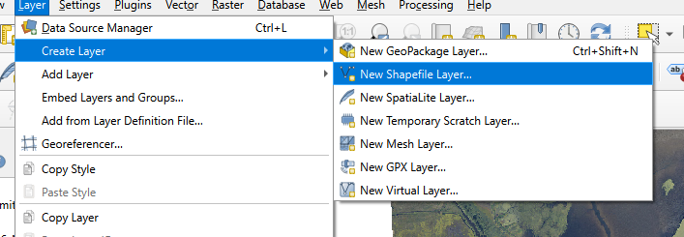

**Step 2** Save your shapefile to the same location as your exercise two, name this layer “Landcover Types.shp”. For the **Geometry Type** select “polygon.” In the **New Field** window create a **Text** field called “class.” Make sure to click **Add to Fields List.** Click **Ok.** Your new layer should appear in the layers panel.

**Step 3** Right click on your new layer in the **layers panel.** Select **Toggle Editing.** The layer can now be actively edited.

**Step 4** Click on the polygon tool  in the upper left of the screen. This tool allows you to add new polygons to your shapefile. To add a polygon, left-click to begin a shape and add addition vertices. To finish a shape **right-click.** Use this process to add polygons that cover (a) a fresh clearcut (b) a lake (c) an older clearcut (d) a mixed forest (e) coniferous forest in the **2006** **RGB image**. When you finish a polygon make sure to note the landcover type in your “class” field.

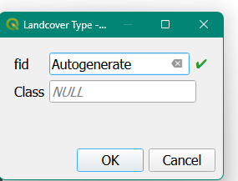

**Step 5** once you have finished right-click on your layer in the **Layers** panel to save the layer edits. Additionally, change the **symbology** of this layer to show the individual layer attributes. See an example in Figure 3.1.

|  |
| --- |
| Figure 3.1: Landcover types for polygon based on interpretation of 2006 aerial RGB imagery. *Note that 2008 is shown in background* |

**Step 5** We will now introduce the **processing toolbox**. This is a great resource for finding tools that help analyze spatial data. The processing toolbox is normally located on the upper right-hand of of the QGIS window. If it is not there, you can load it by going to **View -> Panels -> Processing Toolbox.**

|  |
| --- |
|  |

**Step 6** In the search bar located at the top of the **processing toolbox** type in “Zonal” and select **Zonal statistics.** In the pop-up window make the following selections

1. **Input layer:** Select your class polygons
2. **Raster layer**: Select the **2006 RGB** image
3. **Raster band:** Select the green band
4. **Output column prefix:** type “*Brt” (for pixel brightness values*)
5. **Right click on the “…” in statistics to calculate.** In the new menu select (1) Mean (2) St Dec (2) Minimum and (3) maximum
6. **Save the file to the same location as your exercise 2**

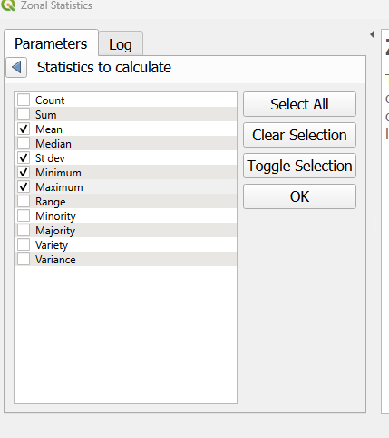

**Step 7** Using the new shapefile, color the shapefile by mean brightness. Under **symbology** select “graduated” and for the color palette choose “greys.” At the top to the color palette window choose **invert color ramp**. Inverting the color ramp means that the polygons where the mean brightness values is low will be closer to black and polygons where the mean brightness is high will be closer to white.

**Step 8** We will now create a new map layout to showcase some the forest cover polygons we have created. Go to file **New print layout** andcreate a new map layout named “forest cover polygons.” Make the orientation of new map **horizontal.** Our new map layout will have three different maps. The first, will describe the forest cover polygons we have created. The second, will describe in the mean brightness for the RGB data we have. Finally, we will have a third map that will look at the variability in these brightness responses.

**Step 9** We’ll start with the map the describes our forest polygons.

1. change the symbology of the forest polygons shapefile to give each polygon a unique color. Go to symbology -> categorized -> select your “class” field -> and classify. Click **Apply** but NOT **ok.**
2. On the left-hand of this pop-up window go to “labels” and select **Single Label** for **Value** select your “class” field.
3. Click on **Buffer** and check the box that says **Draw text Buffer** this will put a small white buffer around our labels
4. Click on **Placement** change the **mode** to **Offset from centroid**. Click the box that says **Allow placing of labels outside of polygons.** Change the **Quadrant** to the upper-left
5. Click **Apply** - labels should now appear on the map canvas
6. Click **Ok.**

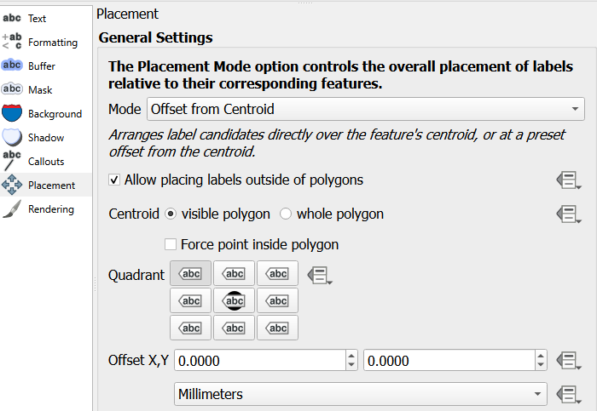

1. Navigate back to your map layout. Insert a new map for your forest polygons. In the background, include the BC VRI and 2008 RGB image. The screenshot below highlights what should be included. Set the map scale to 70000 to best include all of MKRF.

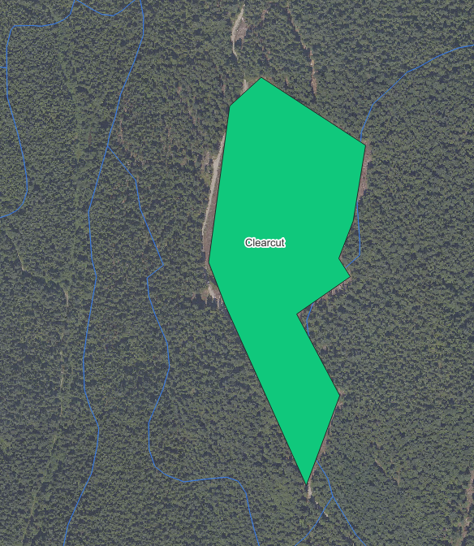

1. In the right-hand side under **Layers** click the checkmark that says **Lock layers and Lock styles for Layers** this prevents your map from automatically updating.
2. Add a legend**.** In **Legend items** uncheck “auto update” and remove all legend items are are not your forest cover polygons. On the forest polygon layer right-click to check “hidden.” In the **Title** for the legend put “Forest Polygon Class”
3. Right click on the map on your map layout to **copy and paste** the map so there is a duplicate map next to your forest polygon map. With this map selected **uncheck** the **Lock layers and Lock styles for Layers**. Navigate back to your map canvas

**Step 9** We’ll now map the average green brightness value in these polygons.

1. Using your layer that we calculated zonal statistics on, which should still be colored black-to-white. Move this layer to the top of the map canvas.
2. Navigate back to your map layout. With the copied map selected change the name to “zonal mean.” In the item properties tab click the circular “refresh” button. This will update the map to the current canvas layers. Click **Lock layers and Lock styles for Layer.**  
   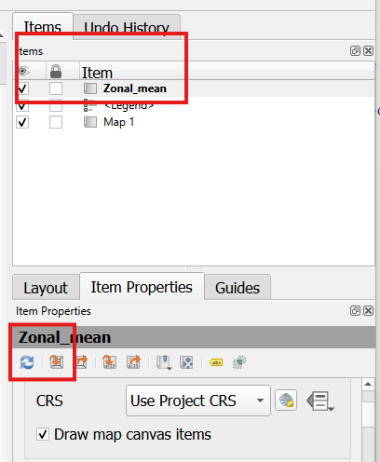
3. Copy the Legend from your polygons layer. Change the reference map to the zonal statistics layer. In the legend properties check “update all”. Change the **Title** to “Mean Bit Brightness (Green Band)”.  
   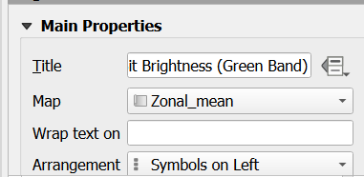
4. Right click on the map on your map layout to **copy and paste** the map so there is a duplicate map next to your forest zonal statistics map. With this map selected **uncheck** the **Lock layers and Lock styles for Layers**. Navigate back to your map canvas.

**Step 10** Follow a similar process to step 9, but this time change the zonal statistics layer to the standard deviation. See Figure 3.2 for an example of your final output.

|  |
| --- |
| Figure 3.2: Example output for forest cover map. **Note your map will be different according to where you place your polygons |

### Question 9:

How do values for your different forest polygons layer differ in terms of brightness? What feature had the highest greenness reflectance? Which feature had the most variable greenness reflectance? Use values to support your results.

### Question 10:

Normally, photo-interpreters would have a 3-D view of a stereo-pair of photos and they could see and measure stand heights. What other information might help the photo-interpreter assign heights to each stand?  HINTS: As well as imagery, what other information might they access? How do other attributes impact height?

### Map 1:

Include your map describing your forest polygon layer and the associated brightness values from the 2006 orthophoto.

## Task 4: Satellite Images Compared to Aerial Photographs

Images collected using satellites provide the base data used to create Google Maps, Google Earth Views, etc. Of these, data collected on Landsat satellites is very commonly used. However, other imagery is often needed to provide finer spatial details, historic views, and 3-D views. You will learn more about other imagery in FRST 538. For now, you will look at the Landsat imagery provided for MKRF and compare these to the aerial photographs. Specifically, you will look at how these images might be used to update for natural and human disturbances.

**Step 1** Add the 2019 Landsat RGB image, keeping both the 2008 and 2006 orthoimages loaded. Clearly, there are differences in the spectral reflectance and the resolution of these two images. However, Landsat is free and is consistently capturing imagery from space every two-weeks (when it is cloud free).

**Step 2** qualitatively compare the orthoimages from the satellite data. Use this to answer the last lab questiosn

Which year (1999 or 1989) had a large polygon size for western red-cedar dominated stands? Please answer in hectares.

### Question 11:

If you were monitoring a forest area for harvest disturbances, would you choose to get new aerial photographs or would you use available Landsat data? Consider the costs, the spatial resolution of the images relative to the disturbance size, and the frequency that images are acquired.

### Question 12:

What about using landsat data for something like small-scale wind damage? Or small-scale fires? What about roads?

## Lab Questions & Deliverables

* ☐ Complete answers to the following questions:
  + ☐ Question 1: Which description of forest composition and structure (VRI and forest cover) has more polygons?
  + ☐ Question 2: Which descriptor of forest composition has a larger average polygon? Which one has a larger maximum polygon?
  + ☐ Question 3: What is the projected age for the polygon at this site? Does this make sense? Why or why not? Insert a screenshot (include a figure caption!) to support your answer.
  + ☐ Question 4: Look for two other forest disturbances or land-cover changes anywhere in MKRF recorded in the 2006 orthomosaic but not recorded in the 2014 VR
  + ☐ Question 5: Malcom Knapp is privately owned land, meaning not all disturbances are consistently added to VRI. Given this, what are some of the disadvantages of relying on VRI alone? What additional tools can we use to better update VRI? Respond in a clear and well written paragraph format.
  + ☐ Question 6: Zoom into the locations noted on the table. Use the  tool located in the upper right of QGIS to retrieve RGB values for the following areas. Once you have filled in the table, discuss why you think different landcovers have different pixel values.

Pixel brightness values for different land cover types in MKRF

| E | N | Landcover | Red Brightness | Green Brightness | Blue Brightness |
| --- | --- | --- | --- | --- | --- |
| 1248400 | 481890 |  |  |  |  |
| 1247760 | 848198 |  |  |  |  |
| 1248195 | 483318 |  |  |  |  |
| 1247019 | 483138 |  |  |  |  |

* + ☐ Question 7: When you look at a clear cut area, what characteristics support an area is harvested? Consider size, shape, texture, proximity to other features, etc. List three specific characteristics to identify a harvested area that you could give to someone else who has never seen an above view of a clear cut.
  + ☐ Question 8: Create a reference table that describes specific characteristics that can help differentiate land cover types using aerial imagery. For each feature in the below table include 3 characteristics of the different land covers.
  + ☐ Question 9: How do values for your different forest polygons layer differ in terms of brightness? What feature had the highest greenness reflectance? Which feature had the most variable greenness reflectance? Use values to support your results.
  + ☐ Question 10: Normally, photo-interpreters would have a 3-D view of a stereo-pair of photos and they could see and measure stand heights. What other information might help the photo-interpreter assign heights to each stand?  HINTS: As well as imagery, what other information might they access? How do other attributes impact height?
  + ☐ Question 11: If you were monitoring a forest area for harvest disturbances, would you choose to get new aerial photographs or would you use available Landsat data? Consider the costs, the spatial resolution of the images relative to the disturbance size, and the frequency that images are acquired.
  + ☐ Question 12. What about using landsat data for something like small-scale wind damage? Or small-scale fires? What about roads?
* ☐ Complete Maps for :
  + ☐ Your photo-interpreted forest polygons. Include the mean and standard deviation for the green birghtness values form the 2006 orthomosaic.
  + Make sure that your map includes:
    - A title
    - A scale bar
    - A north arrow
    - A proper legend

## Summary

# 4. Exercise 3: Simple Sampling Designs

Written by

Sarah Smith-Tripp

## Lab Overview

This lab uses a “simulated” forest to practice simple random sampling, summarizing the data, and then using that information as we would in a real forest environment. We will use this sample data to estimate important forest metrics and confidence around our estimates.

## Learning Objectives

* Estimate the population mean and the confidence intervals using simple random sampling
* Apply estimates + confidence intervals to answer management questions
* Apply a systematic sampling design to estimate population mean and confidence intervals
* Compare the cost and relative efficacy of different sampling regimes.

|  |
| --- |
| Note |
| Prior to completing this exercise go over the terminology and equations included the course lecture material. It is important to know what a *population* mean is and how we describe this using *estimators* |

## Data Overview

**Simulated Forest Landscape**

|  |
| --- |
| Each square is a 14.14 m X 14.14 m plot (0.02 ha plot). Numbers on the top left-hand corners are plot numbers, whereas numbers on the bottom right-hand corner are volumes (m3/0.02 ha). North is at the top of the map |

## Task 1: Simple Random Sampling

**Step 1**

### Question 1

Using the map above select n=15 plots using simple random sampling without replacement. Explain how you used **simple random sampling replacement to select the data**. How did you choose random numbers?

## develop a sample   
plot_sample <- sample(x = 1:112, size = 15, replace = F)

### Question 2

Calculate:

1. Mean volume per plot
2. The estimated plot-to-plot variance
3. The estimated variance of the mean (remember that this is sampling without replacement)
4. The estimated standard error of the mean
5. 95% confidence interval for this mean.

|  |
| --- |
| Note |
| *You must should calculations and include measurement units in your responses. For your confidence interval calculation, shot is a range with the lower value first.* |

### Question 3

Convert the estimated mean volume per plot and the associated confidence interval to an equivalent per hectare estimate (e.g. 200m3/ha with a confidence interval of (100 m3/ha)

### Question 4

Based on the volume per ha values, where in BC might these data have come from? Consider (1) ecosystem type (2) time since disturbances. To provide context, a very productive old stand in the Boreal Forest of Canada could have up to 500 m3/ha (most are much less). A very productive old stand in the Temperate Rainforest of the western coast of Canada could have 1,500 m3/ha. Also, 1 m3 is about the size of a utility pole (e.g., telephone or electricity pole).

### Question 5

How large is total plot area in hectares (you determined this in Activity 3 already)? Use this to expand the mean in m3/ha and the associated confidence interval to obtain the estimated total m3 volume for the land area and a 95% confidence interval for this estimate. Based on this confidence interval, would you say that there could be 1200 m3 of volume in this area?

### Question 6

Calculate the Percent Error achieved for your survey. Did you achieve the desired percent error of  + or – 15% of the mean with 95% probability? NOTE: This is the standard for operational cruising in BC for scale-based sales (i.e., billing is based on scaled logs not on standing estimated cruise volumes).

## Task 2: Systematic Random Sampling

For the following questions imagine a forester is planning a survey with the with the following specifications:

1. Intensity (*I*) = 0.02 (i.e., 2 %)
2. Forest land area (*A*) = 100 ha (1000 m X 1000 m; 1 ha = 10,000 m2)
3. Size of plot (*a*)= 0.02 ha (i.e., 14.14 X 14.14 square plot)

### Question 7

1. The area of the all of the plots of that will be needed for this forester’s survey using this intensity (A*p*); and
2. The number of samples (*n*) required for this desired sampling intensity, given the specified plot size.

### Question 8

Given that the length between plot centres (*B*) is fixed at 40 m, what is the length between lines (*L*)? **NOTE:** In practice, we would round down to the nearest 5 m to lay this out in the field. For example, if the answer was 103 m, we would use 40 m by 100 m spacing (not 105 m and not 103 m spacing), since forest land areas are often irregular in shape and this would “pull in” the systematic sampling grid to hopefully get enough plots.

What would the spacing be, if this square spacing between plot centres was used instead? Again, in practice, we would round this answer down to the nearest 5 m to lay this out in the field.

Which of these two options would you choose to use and why?

### Question 9

Using the square spacing calculated in 2b and the plot size, select random co-ordinates for you first plot centre in the first “grid” of your systematic survey. Show all calculations you used to get the random co-ordinates and to make sure that the plot will fit within the first “grid square” of your systematic survey given these random co-ordinates and the plot dimensions.

### Question 10

Given a fixed project cost of $5,000 (i.e., truck rental and other equipment) and a per day cost of $1,000 for a 2-person crew with a production rate of eight plots per day:

1. How long would the survey take?
2. What would the cost of this survey be?

### Question 11

if the budget was set at $10,000:

1. How many plots could you have measured using the cost estimates in #10?
2. What would the sampling intensity be for this fixed budget?
3. Would this sampling intensity be more or less than the sampling intensity used in the sample plan (i.e., planned for 2%)?

## Lab Questions & Deliverables

* ☐ Complete answers for all 11 following questions:
  + ☐ Questions should show all work including calculations
  + ☐ If you used code, make sure to include the code you used to answer the question.

## Summary

In this lab, we practiced the calculations of important summary statistics from a random sampling design. We also learned and applied our investigation to look at sampling intensity in systematic random sampling.

# 5. Exercise 4: Compilation of Fixed-Area Plots to a Stand Level

Written by

Sarah Smith-Tripp

## Lab Overview

This lab builds on our previous work to introduce more stand-level summaries as well as using forest data to summarize important forest attributes like volume and biomass. You will work with formulas, created from test data, to understand a forest-stand. Using your estimates you will produce a data summary for a landowner. You may work in groups for this lab, but each student must be able to run the code on their own computer.

## Learning Objectives

* Practice analysis of fixed-area plots to obtain plot summaries.
* Use simple random sampling to summarize plot-level data to obtain a stand-level summary
* Summarize tree-level data to obtain plot-level stand and stock tables. Use this tree level data to obtain stand-level stock and stand tables

## Problem Introduction

**General Description**

A landowner hires you to conduct a survey of a 30-ha forested parcel of land (BC Coast). In particular, the owner would like to know how much they could make on the carbon market if they kept this forest intact and sold the carbon credits. From reading several documents, you find out that: 1) about 50% of aboveground biomass is carbon; and 2) the rate for carbon credits is about $65 CAD per C tonne. The owner would also like to know general information about the timber characteristics for general management purposes.

## Key Formulas

For today’s data investigation we will use formulas created by the ministry to calculate volume and dry biomass for different tree species in British Columbia. Models for volume use Schumaker’s volume function. The coefficients are described in the table below.

$$ Volume(m^3) = 10^{(A +B(Log_{10}(DBH(cm))) + C*(Log_{10}(Height(m))))}$$

BC Ministry of Forest Volume Coefficients

| Tree Types | A | B | C | Source |
| --- | --- | --- | --- | --- |
| immature western red cedar | 4.14 | 1.72 | 1.05 | BC |
| Traditional |  |  |  |  |
| immature western hemlock | -4.42 | 1.87 | 1.10 | BC |
| Traditional |  |  |  |  |
| immature douglas fir | -4.32 | 1.81 | 1.04 | BC |
| Traditional |  |  |  |  |
| mature western red cedar | -4.10 | 1.74 | 0.98 | BC |
| Traditional |  |  |  |  |
| mature western hemlock | -4.34 | 1.78 | 1.12 | BC |
| Traditional |  |  |  |  |
| mature douglas fir | -4.35 | 1.69 | 1.18 | BC |
| Traditional |  |  |  |  |
| red alder | -4.43 | 1.78 | 1.09 | BC |
| Traditional |  |  |  |  |
| bitter cherry | -4.43 | 1.78 | 1.09 | BC |
| Traditional |  |  |  |  |

Similarly, Biomass equations use the following formula:

$$Biomass=Intercept+Slope*DDH$$

Where DDH is the diameter squared times the height of the tree.

$$DDH=\left(DBH\left(cm\right)/100\right)*\left(DBH\left(cm\right)/100\right)*Height\left(m\right)$$

| Tree Types | Intercepts | Slope |
| --- | --- | --- |
| mature western red cedar | 40.4 | 96.9 |
| mature western hemlock | 29.8 | 155.8 |
| mature douglas fir | 37.2 | 139.3 |
| red alder | 4.8 | 206.5 |
| bitter cherry | 4.8 | 206.5 |

## Data Description

You decide to use a systematic sampling approach to determine plot centres for *n*=4 plots. For each plot center, you establish a circular, fixed-area plot (r=11.27 m; 0.04 ha) aiming to sample all trees which are ≥ 2.0 cm DBH within this radius. Some plots had a lot of trees and thus a process of “Half Sweeps” was conducted, where a randomly chosen half of the 0.04 ha (or a slice) was selected and only trees in that half of the plot were recorded (i.e., each tree counts twice in the 0.04 ha plot OR the plot size was reduced to 0.02 ha).

For each tree (DBH≥2.0 cm) in the plot (full or half plot), the species was recorded and the DBH (cm) was measured. On a subset of trees, the height (m) was measured in the field. For the remaining trees, the height was estimated in the office using existing height/DBH models (i.e., for each tree without height, the species-specific models developed for this area were used to estimate height from DBH).  For broken trees, the height to the break was measured in the field, and an estimate of the height that the tree might have been if not broken was also recorded in the field. A snapshot of these data are provided below.

From these data, you determine the characteristics of the forest land and report these to the landowner, along with your estimate of potential carbon credits.

Description of four selected plots including # trees & plot type

| PlotNo | number_trees | plot_type |
| --- | --- | --- |
| 1 | 15 | Half |
| 2 | 21 | Full |
| 3 | 10 | Half |
| 4 | 12 | Full |

## Plot Level Analyses

Following the example code below (using fake data!) use the *real* data included in your lab exercises to calculate the average tree size in terms of DBH, height and basal area per tree, total volume per tree, and biomass. Remember to report the measurements units for each of these metrics. The code below includes both a right and a wrong version. In your analysis, discuss which version you used and why. Additionally, there were some useful formulas created to analyse data in lab 3. We’ll be working work this code for our analyses. Click the down-arrow to look at these functions

set.seed(1234)  
# load packages   
library(pacman)  
p_load(tidyverse, ggplot2, dplyr)  
## set up some useful functions   
## variance around the maean   
var_simple_random <- function(data){  
 #data = numeric vector of dataset  
 ybar <- mean(data, na.rm =T) ## calculate the mean  
 top_sum <- sum((data - ybar) ^ 2)  
 df <- length(data)  
 var_simple <- top_sum/ (df-1)  
 return(var_simple)  
}  
## standard deviation w and without replacement   
sd_simple_random <- function(data, replacement = T, N_big = NULL) {  
 #data = numeric vector of dataset  
 #replacement = a logical value indicating whether sample is with or without replacement   
 #N_big = an optional numeric value representing the total population size when sampling without replacement  
 ybar <- mean(data, na.rm = T) ## calculate the mean  
 top_sum <- sum((data - ybar) ^ 2)  
 df <- length(data)  
 var_simple <- top_sum / (df - 1)  
 if (replacement == F) { # replacement is NOT true  
 ## adjustment neded to control for the limited sampel  
 if (length(N_big) == 0) {  
 return('Total Possible Needed')  
 } else if (length(N_big) > 0) {  
 adj_fct <- (N_big - df) / N_big  
 sd_mean = (var_simple / df) * adj_fct  
 return(sd_mean)  
 }  
 }  
 else {  
 sd_mean = var_simple / df  
 return(sd_mean)  
 }  
}  
## confidence intervals for mean of population  
confident_interval <- function(x, alpha = 0.05){  
 #data = numeric vector of dataset  
 #alpha = confidence interval (default is 0.95)  
 n <- length(x)  
 mean_x <- mean(x, na.rm = T)  
 ## this is the sd of the mean   
 se <- sd(x, na.rm =T)/sqrt(n)  
 t_value <- qt(1 - alpha/2, df = n - 1)  
 ## confidence ofthe mean of the population  
 ci <- mean_x + c(-1, 1) * t_value * se  
 return(ci)  
}  
new_sample_size <- function(Allowable_Error,   
 data,  
 replacement = TRUE,  
 N = 100) {  
 #Allowable error = error in decimal allowed in the new dataset   
 #data = numeric vector of dataset  
 #replacement = a logical value indicating whether sample is with or without replacement   
 #N_big = an optional numeric value representing the total population size when sampling without replacement  
 ## calculate confidence interval   
 CI <- confident_interval(data)  
   
 ## percent error   
 PE <- (diff(CI) * 0.5) / mean(data) * 100  
   
 ## calculate mean  
 mean_val <- mean(data)  
  
 #test_stat <- mean_val - 0.95 / (var(data)^0.5)  
 t_val <- qt(0.95, df = length(data)-1, lower.tail = T)  
 t_val  
 sd_ <- sd(data)  
 CV = (sd_ / mean_val) * 100   
 if (replacement == FALSE) {  
 Q <- Allowable_Error^2 / (t_val^2 * CV^2)  
 n_out <- 1 / ((1 / N) + Q)  
 n_out  
 } else {  
 n_out <- (t_val^2 * CV^2)/ Allowable_Error^2  
 }  
 return(round(n_out))  
}

#### First we will calculate the tree level variables

*Note this code also shows how to read in the real data*

## read in our data   
plot_data <- read.csv("Lab4_Plotdata.csv")  
## we are using fake data here   
species_list <- unique(plot_data$Species)  
## species mapping   
species_fullnames <- c('Cw'='western redcedar', 'Hw'='western hemlock', 'Fd'='douglas fir', 'Ra'='red alder', 'Bc'='bitter cherry')  
## convert species in the volume coefficients factor   
## assuming all trees are mature   
p_load(stringr)  
coeff_vol_bio_mat <- filter(volume_df, str_starts(tree_types, "mature") & Type ==  
 'BC\nTraditional') %>%   
 mutate(short_names = case_when(tree_types == 'mature western red cedar' ~ 'Cw',  
 tree_types == 'mature western hemlock' ~ 'Hw',   
 tree_types == 'mature douglas fir' ~ 'Fd')) %>%   
 left_join(biomass_df, by = c('tree_types' = 'trees_types_biomass'))  
  
## create a random list of species  
fake_data <- data.frame(Species = sample(species_list, 100, replace = TRUE),   
 DBH = rnorm(100, 30, 2),  
 Height = rnorm(100, 25, 5),  
 PlotNo = sample(1:4, 100, replace = TRUE),  
 Partial = sample(c("Full", "Half"), 100, replace = TRUE),  
 Treeno = seq(1, 100, by = 1))  
## using fake data and the volume coefficients and the species fullnames calculate the volume for each tree  
fake_data_calcs_tree <- fake_data %>%  
 #Join the volume coefficients onto the data frame   
 left_join(coeff_vol_bio_mat, by = c("Species"="short_names")) %>%   
 #Group by tree ID   
 group_by(Treeno) %>%  
 mutate(BA = (sqrt(DBH/(2*100)) * pi), # basal area per tree  
 Vol = (10^(A + (B*log10(DBH)) + (C*log10(Height)))),## volume per tree  
 biomass = int + (slope * ((DBH/100)^2) * Height)) #biomass per tree  
head(fake_data_calcs_tree)

# A tibble: 6 × 16  
# Groups: Treeno [6]  
 Species DBH Height PlotNo Partial Treeno tree_types A B C Type   
 <chr> <dbl> <dbl> <int> <chr> <dbl> <chr> <dbl> <dbl> <dbl> <chr>  
1 DD 26.4 23.1 3 Half 1 <NA> NA NA NA <NA>  
2 DD 28.8 25.5 2 Half 2 <NA> NA NA NA <NA>  
3 Fd 27.8 33.2 4 Half 3 mature dou… -4.35 1.69 1.18 "BC\…  
4 Fd 28.0 20.6 2 Half 4 mature dou… -4.35 1.69 1.18 "BC\…  
5 Cw 29.7 25.6 4 Half 5 mature wes… -4.1 1.74 0.98 "BC\…  
6 DD 31.1 31.8 1 Half 6 <NA> NA NA NA <NA>  
# ℹ 5 more variables: int <dbl>, slope <dbl>, BA <dbl>, Vol <dbl>,  
# biomass <dbl>

#### Then we will calculate the per hectare variables for each tree

## option a   
opt_A_pHa <- fake_data_calcs_tree %>%   
 ## Add in plot adjustment  
 mutate(SPH = 1/0.04) %>%   
 group_by(Treeno) %>%   
 mutate(BA_pHa = BA * SPH,   
 Vol_pHa = Vol * SPH,   
 biomass_pHa = biomass * SPH)   
# option b   
opt_B_pHa <- fake_data_calcs_tree %>%   
 ## Add in plot adjustment  
 mutate(SPH = ifelse(Partial == "Half", 1/0.02, 1/0.04)) %>%   
 group_by(Treeno) %>%   
 mutate(BA_pHa = BA,   
 Vol_pHa = Vol,   
 biomass_pHa = biomass)  
trees_pHa <- opt_B_pHa

#### Finally, we can calculate the plot and stand-level variables

## option a  
opt_A_plot <- opt_A_pHa %>%   
 ## Group by plot  
 group_by(PlotNo) %>%   
 summarise(mean_DBH = mean(DBH, na.rm = T),   
 mean_Height = mean(Height, na.rm = T),   
 mean_BA = mean(BA, na.rm= T),   
 mean_Vol = mean(Vol, na.rm =T),   
 mean_biomass = mean(biomass, na.rm = T),  
 mean_BApHa = sum(BA_pHa, na.rm =T),   
 mean_VolpHa = sum(Vol_pHa, na.rm = T),  
 mean_biomass_pHa = sum(biomass_pHa, na.rm = T)) %>%   
 summarise_all(mean)  
## option b  
opt_B_plot <- ungroup(opt_B_pHa) %>% ## ungroup data to calculate stand level means   
 mutate(Adjst = ifelse(Partial == "Half", 0.5, 1)) %>%  
 reframe(mean_DBH = mean(DBH, na.rm = T),   
 mean_Height = mean(Height, na.rm = T),   
 mean_BA = mean(BA, na.rm= T),   
 mean_Vol = mean(Vol, na.rm =T),   
 mean_biomass = mean(biomass, na.rm = T),  
 mean_BApHa = mean_DBH * SPH * Adjst,   
 mean_VolHa = mean_Height * SPH * Adjst,   
 mean_biomasspHa = mean_biomass * SPH * Adjst) %>%   
 distinct()

### Question 1

In the the code chunks above which options correctly calculated: A. the tree-level per hectare variables? Why? B. the stand-level variables? Why?

### Question 2

Using you answer to question 2 adjust the code below to also calculate confidence intervals for biomass per hectare.

#### Calculating Confidence intervals for DBH and Mean Height

## calculate the confidence intervals for the mean of the population  
## for the mean DBH  
adjust_confidence_func <- function(x, alpha, confident_interval) {  
 splitted <- str_split(confident_interval(x, alpha = alpha), ' ')  
 out <- paste0( round(as.numeric(splitted[[1]]), 2),'-', round(as.numeric(splitted[[2]]),2))  
}  
  
confidence_intervals <- trees_pHa %>%   
 ## Group by plot   
 group_by(PlotNo) %>%   
 summarise(DBH_means = mean(DBH, na.rm = T),  
 Height_means = mean(Height, na.rm = T),  
 stems_per = ifelse(Partial == "Half", n()*2, n()) * (1/0.04),   
 volume_pHa = sum(BA_pHa, na.rm = T)  
 ## Add values here to calculate by plot   
 ## e.g.  
 #biomass_per = sum(biomass_pHa)  
 ) %>%  
 ungroup() %>%   
 summarise(DBH_CI = adjust_confidence_func(DBH_means, 0.05, confident_interval),  
 mean_DBH = round(mean(DBH_means, na.rm = T), 2),  
 Height_CI = adjust_confidence_func(Height_means, 0.05, confident_interval),  
 mean_Height = round(mean(Height_means, na.rm = T),2),  
 volume_CI = adjust_confidence_func(volume_pHa, 0.05, confident_interval),  
 mean_volume = round(mean(volume_pHa, na.rm = T),2),  
 stems_CI = adjust_confidence_func(stems_per, 0.05, confident_interval),  
 mean_stems = round(mean(stems_per, na.rm = T), 2))  
 ## add values here to calculate for the stand-level   
confidence_intervals %>% kable(., caption ="Confidence Intervals & mean values for DBH, Height, Volume, and Stems")

Confidence Intervals & mean values for DBH, Height, Volume, and Stems

| DBH_CI | mean_DBH | Height_CI | mean_Height | volume_CI | mean_volume | stems_CI | mean_stems |
| --- | --- | --- | --- | --- | --- | --- | --- |
| 30.1-30.22 | 30.16 | 25.66-25.71 | 25.68 | 30.65-33.49 | 32.07 | 897.27-1049.73 | 973.5 |

### Question 3

Calculate the estimated total volume and total biomass for the 30-ha area and a 95% confidence interval for each of these with measurement units

mean_volume <- confidence_intervals$mean_volume * 30  
#mean_biomass <- confidence_intervals$mean_biomass * 30

### Question 4

What is the estimated carbon (tonnes) and estimated carbon credits ($CAD) and 95% confidence intervals for the 30-ha area? *Remember: biomass estimates are in kg*

### Question 5

Using your formatted data, create a table that summarizes the plot and stand-level variables by DBH class and species. In this instance, we will need to the group the data by both Plot & DBH class prior to summarizing the data. The code below shows this to the plot level. Adjust the code to also summarize the data to the stand level. See an example of plotting below:

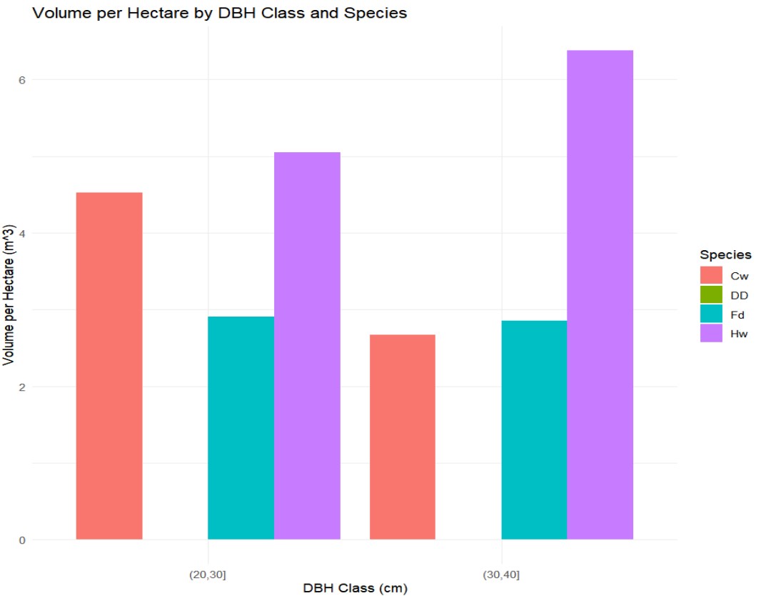

## using our trees_pHa data  
# create DBH cutoffs every 10 cm  
plot_stock_table <- trees_pHa %>%   
 mutate(DBH_class = cut(DBH, breaks = seq(0, 100, by = 10))) %>%  
 #Group by DBH, Species, AND plot number (i.e grouping by plot prior to summarising)  
 group_by(PlotNo, DBH_class, Species) %>%  
 summarise(mean_DBH = mean(DBH, na.rm = T),  
 mean_VolpHa = sum(Vol_pHa, na.rm = T)) %>%   
 ## Group by species and DBH class   
 ## Drop plot level grouping  
 group_by(DBH_class, Species)   
 ## add the stand level summary here  
  
## we can plot use this plot the data   
# ggplot(plot_stock_table, aes(x = DBH_class, y = mean_VolpHa, fill = Species)) +   
# geom_bar(stat = "identity", position = "dodge") +   
# theme_minimal() +   
# labs(title = "Volume per Hectare by DBH Class and Species",   
# x = "DBH Class (cm)", y = "Volume per Hectare (m^3)")

## Reporting

Prepare a short summary report for the landowner that includes the following:

1. An introduction to the report including the location of the survey, type of forest and size of the forest, along with the survey objectives.
2. A methods section indicating how the data were obtained (Sampling design? Spacing? Random start? Plot size? Map of plot centres? What was measured for each tree in each plot?
3. A results section providing a summary of the important information about this stand, using Q1 to Q4 to guide you on what to include in this section (What would you want your reader to know about the stand? Tree size? Volume perha and biomass per ha? Species composition?). Include tables to support your results. *Make sure to include captions and units for all tables and figures*
4. A clearly arranged appendix including your code and answers to the questions in this lab.

## Lab Questions & Deliverables

* ☐ *Individuals* Complete answers for all 5 questions in the lab *including code when asked*
* ☐ *Group* A summary report for the landowner including an introduction, methods, results, and an appendix with code and answers to the questions in this lab.

## Summary

In this lab, we used R to calculate important plot and stand level attributes. We used these attributes to produce a summary report for a forest stand that will be given to a landowner. We also calculated confidence intervals for our estimates to provide a measure of uncertainty around our estimates.

# 6. Exercise 5 - Volume, Biomass, and Taper Models

Written by

Sarah Smith-Tripp

## Lab Overview

|  |
| --- |
|  |

To gain a better understanding of how to use tree allometric models for volume, taper, merchantable length/height, log volume, and biomass. If you are comfortable working with R or python for this lab please feel free to do so. This lab does not require using R for final computations. To successfully run this lab in code format feel free to talk to your TA. Instructions are given for the excel version.

## Learning Objectives

* Use allometric equations to get merchantable volume, merchantable length and height, log-volum, and biomass.
* Compare the results of different volume models.
* Engage with scientific literature to find relevant models to calculate biomass and volume

## Task 1 - Total Volume

**General Description**

### Question 1

1. Calculate the estimated total tree volume for a hybrid spruce (Picea *glauca* (Moench) Voss X P. e*nglemannii* Parry ex Engelm.) tree growing in the ESSF near Smithers, BC with a DBH=80.0 cm and height= 35.0 m using the Kozak (2002) taper model.
2. Use the EXCEL example provided modify necessary values for DBH, height, and betas (see the top of the sheet).
3. Once modified, get the total volume as well as a taper graph. Input both of these as your answer to question

### Question 2

Calculate the estimated total tree volume for a hybrid spruce (Picea *glauca* (Moench) Voss X P. *englemannii* Parry ex Engelm.) tree growing in the ESSF near Smithers, BC with a DBH=20.0 cm and and 12.0 m in height. Do this as well for a tree of 100 cm and 42.0 m in height. In your answer for this question, include a 3 row table with the volumes, DBH, and height of each tree.

### Question 3

Compare the estimated taper shape for the original tree to the smaller and larger trees in a short report. Why would this shape change for different tree sizes? How does this “help” the tree? Give at least two reasons why the shape changes as the tree size gets larger. Add in the three graphs of tree shapes to your short report to support your statements.

## Task 2 - Merchantable Volume

### Question 4

Use the Kozak (2002) taper model again, but this time to calculate the estimated merchantable volume for the large tree from a 0.3 m stump height to a 10.0 cm top diameter inside bark. Some parts of the tree will not be included in this merchantable volume and will have a zero volume, namely the stump segment, and the parts of the tree above 10.0 cm top diameter inside bark. You will have to modify the section lengths to obtain a 10.0 cm top diameter inside bark and then sections higher than this will have a zero volume. What is the merchantable tree volume? Again, keep four decimals only.

### Question 5

Determine the estimated merchantable height (i.e., ground to merchantable limit) and the estimated merchantable length (i.e., stump to merchantable limit) of this tree. You will not be modifying your Merchantable Volume worksheet for this; instead, use the worksheet to get the answers (i.e. when is the tree too small in width). The merchantable length and merchantable height will be in m. By convention, we keep one decimal place for tree heights and for merchantable lengths. NOTE: We often keep two decimals for distances, and for log lengths, however, and we keep one decimal place for DBH in cm.

### Question 6

What is the merchantable volume over total volume proportion? If the tree was larger, would this proportion be smaller or larger?

### Question 7

How many logs of 2.5 m long could we get from this tree, within the boundaries of the stump height and the minimum diameter inside bark of 10.0 cm? What could be done with the rest of the merchantable part of the tree?

### **Question 8** *Bonus*

What is the value of the first log (i.e., the largest one starting at stump height) in CAD, assuming it is a high-quality log (i.e., no decay, no knots, few growth rings per inch, and no defects)? HINT: You will need to look up log prices online. You may also need the log grade given the species, log size, and condition to estimate a likely log price.

## Task 3 - Whole Tree Volume Models

For the same tree large hybrid spruce as in Question 1 of Part I, calculate the estimated total volume using the BC coefficients based on Schumacher’s model (Schumacher and Hall, 1933), but fitted using BC tree data, and compare this to volume using Kozak’s model.You will need to use the Key Equations from Excercise 4 to calculate the volume using the mature douglas fir coefficients. ### Question 9 {.unnumbered} Compare this to the estimated total volume you calculated using Kozak’s taper model for this large hybrid spruce. NOTES: Since these were both found using models, they are both estimated volumes. However, on one hand, the volume models would be expected to be more precise for estimating tree volume since they estimate this directly whereas the volume using the taper model are calculated by first calculating the estimated diameters inside bark up the stem. On the other hand, taper models can be used for more than just estimated total volume (i.e., merchantable volume, log volumes, etc. as you did in Task 1 & 2).

## Task 4 - Engaging with the literature

### Question 10

1. You used biomass models by Standish et al. (1985) in Exercise 4 to find aboveground total biomass for trees in fixed-area plots. Find the following publication for tree biomass models of several species in Australia:

|  |
| --- |
| Search the Literature |
| Bi H, S Murphy, L Volkova, C Weston, T Fairman, Y Li, R Law, J Norris, X Lei, G. 2015. Additive biomass equations based on complete weighing of sample trees for open eucalypt forest species in south-eastern Australia. Forest Ecology and Management Volume 349, pages 106 to 121. https://doi.org/10.1016/j.foreco.2015.03.007 |

Then, estimate the aboveground biomass (kg) for a E. regnans that is 120.0 cm DBH (Note: Measured at 1.37 m above ground in Australia) and 51.0 m in height. For this, use Eq. 8 that uses DBH only (labelled as D, cm) or Eq. 10 that uses D2H,(DBH (cm) squared time height (m)) from the paper. The parameter estimates for each of these models and that species are found in Table 2. You will need to calculate the total stem biomass and the crown biomass first, and add them together to get total tree (aboveground) biomass, as shown in Eq. 8 or 10, to get aboveground biomass.

|  |
| --- |
| Note |
| NOTE: You might want to input these DBH and height measures into Standish et al. (1985) biomass model for mature Coastal Douglas-fir that you already used in Exercise 4 to estimate the kg and use that as a rough guide as to what the estimated biomass might be for this *E. regnans* tree using the Bi et al. (2015) models. |

### **Question 11** *Bonus*

Find a publication with a tree biomass model for white spruce (Picea glauca (Moench) Voss growing in Ontario, Canada. Give the full citation for this publication. (See Question 10 for an example of a full citation).

## Lab Questions & Deliverables

* ☐ Complete answers for all 11 questions in the lab *including graphs and tables with captions and proper units*

## Summary

In this lab, we used a taper model to estimate total tree volume, merchantable volume, merchantable height, and merchantable length. We also compared the results of different volume models and engaged with scientific literature to find relevant models to calculate biomass and volume.

# 7. Exercise 6: VDYP & TIPSY for Forecasting Inventory Records

## Lab Overview

For timber supply (and other forest-level analyses), forecasts of each stand (or aggregates of similar stands) are needed to evaluate different management scenarios. For these analyses, yield tables for each stand type and management regime are needed to make these forecasts. In BC, VDYP is used for “unmanaged” stands and TIPSY is used for “managed” stands. There are other models (e.g., PrognosisBC) also available for use by BC forest professionals.

|  |
| --- |
| Growth & Yield Models in BC |
| **TIPSY**   * For managed stands * Used in Timber Supply Analysis for managed stands (i.e., post harvest) * Can also be used for “silvicultural gaming” * Prorates pure species stand yields to get mixed species stand yields (as does VDYP) * Can add silvicultural treatments * Look up forecasts from a database using the input variables you supply   + Where did this database come from? Run TASS -> get yield tables and other things -> add to TIPSY’s database -> now ready to use in TIPSY - Where is TASS from?   + About 50 years of research using primarily data from experimental installations (not representative of the landbase) * Limited options – More in TASS (not yet available to everyone) * When you run TIPSY, you get access to TIPSY help – very useful!! Lots of info there. * **Inputs needed** (* indicates these are optional)   + Species composition   + OAFs: The TASS and TIPSY yields will be too high because they assume no forest gaps, and low rates of pathogen/insect attacks. * **Outputs obtained**   + Volume per ha over age   + MAI (m3/ha/year) over age * **VDYP** * For “naturally-regenerated” stands (so-called “unmanaged” stands) * Used in Timber Supply Analysis for unmanaged stands (i.e., naturally regenerated) * Data used is more representative of the land base (not simple random sampling, but more representative) * Prorates yields of pure species stands to get mixed species (as does TASS) * **Inputs needed**   + Species composition   + BEC zone   + Site productivity: Site index OR site height + age (SI calculated)   + Density * **Outputs obtained**   + Volume per ha over age   + MAI (m3/ha/year) over age   + **TASS** * Tree-level distance dependent model developed for managed stands * Is the “engine” behind TIPSY database * New version coming out soon (beta-testing right now) that will be available to more users * Grows each tree crown and then the stem from this crown growth * Competition depends on overlap of crowns * 50 years of research * **SORTIEBC** * Tree-level distance dependent model that is considered a “hybrid” model since competition is based on light interception by crowns * Limited support by BC MFLNRO right now * SORTIE was originally developed by Canham in the USA. * **PROGNOSIS BC** * Tree-level, distance independent model for mixed-species stands (managed or natural) * Is the GY model behind the FVS system (most locations, not all) that has been adopted for use throughout the USA. * Not supported by BC MFLNRO right now (“moth-balled”) * Original Prognosis model was developed by Stage (1973 publication) * **Others** * Forsyte, Forsee, Fortoon: Developed by Kimmins, professor emeritus at UBC. A hybrid model. Zelig: GAP model MGM: Developed for mixed species stands at the University of Alberta by Titus * *every province has its own collection (e.g. PROGNOSIS Ontario, GYPSY (Alberta), etc.)* |

To become familiar with how VDYP and TIPSY can be used to forecast the growth and yield of stands, you will forecast three polygons from MKRF. You will use the VRI forest inventory, layer 1 attributes, as inputs to VDYP. This links the VDYP model to forest inventory information, which is what happens for “unmanaged” stands in timber supply analyses. You will then simulate harvests of these stands and forecast future growth and yield post-harvest using TIPSY.

## Learning Objectives

* Understand the application of TIPSY and VDYP on the landbase
* Utilize TIPSY and VDYP to better understand forecasting for management decisions.

## Task 1 VDYP: Stand-level Yield Forecasts using VRI as Inputs

You looked at the 2014 VRI forest cover for MKRF in FRST 556, Ex.1 and 2. Using these data, all stands where western redcedar (*Thuja plicata*) was species with the largest percent were selected using QGIS. The attributes were exported as a .csv file, which was sorted, attributes were trimmed (i.e., some attributes were removed), and then the results were saved as CW dominated polygons trimmed.xlsx. Three of these stands in the northwestern part of MKRF were selected as stands of interest (CW dominated three polygons trimmed.xlsx). A few of the attributes of these polygons are shown in Table 8.1, and an image of the location of these stands is shown in Figure 1

Table 7.1: Table 1. Three polygons selected from the western redcedar dominated stands of MKRF (Data Source: VRI 2014 forest cover map, layer 1).

| LY_ID | LBL_SPECIS | EST_SI_SPC | EST_SI (m) | CR_CLOSURE (%) | Shape_Ar (in ha) |
| --- | --- | --- | --- | --- | --- |
| 611 | CwHw(Fd) | CW | 20 | 65 | 11.1 |
| 621 | CwHw(Fd) | CW | 21 | 65 | 2.1 |
| 622 | CwHw(Fd) | CW | 18 | 70 | 7.1 |

|  |
| --- |
| Table Notes |
| • POLY_ID is the ID for the polygon: • LBL_SPECIS shows the species from the highest to lowest percent (species in brackets have very low percentages) • EXT_SI_SPC is the species used for the site index reported; EST_SI is the site index for the stand in m; • CR_CLOSURE is the percent of the ground covered by trees; and • Shape_Area is reported in m2 by QGIS (and in ARCGIS software), but these have been converted to ha (This may be less than POLY_AREA in the VRI data, since the polygon may extend outside of the MKRF boundary). |

|  |
| --- |
| Figure 1. Map of three selected (in green) western redcedar dominated polygons of MKRF. (Data Source: VRI 2014 forest cover map, layer 1). |

In the CW dominated three polygons **trimmed.xlsx** file, you will also find the species percentages for these three selected polygons, and other attributes that you may need as inputs to VDYP to forecast this stand. Using VDYP, forecast these three stands from 0 to 250 years total age at 10-year intervals. You will get a yield a yield trajectory for each attribute in each of three stands (i.e., total volume per ha, merchantable volume per ha, stems per ha, etc. over time).

1. To get you started, first do the example stand in the Quick Intro to VDYP7.pdf (or .docx) file to get the yield trajectory, export these to EXCEL, trim off any labels, and then graphs the trajectories.
2. Use similar steps to get forecasts for each of these three stands, and export growth and yield table to an EXCEL file. Include merchantable volume (12.5 + cm DBH) in your outputs, as well as the MAI’s for total and merchantable volume. (See POLYGON1 2020 VDYP trimmed.xlsx as an example of VDYP outputs for a stand).
3. Using these growth and yield outputs, answer the questions posed and put these answers in your submission

### Question 1 (VDYP Questions)

1. Graph the total volume per ha (m3/ha) over total age (years) for each stand.  Which stand appears to be the most productive? Explain your answer.
2. Graph the total volume mean annual increment (MAI or m.a.i., m3/ha/year) over total age for each of these three stands.   What is the biological rotation age for each stand?

|  |
| --- |
| Figure 2. Example of the total volume per ha and MAI for three selected stands. |

1. Repeat #2, but this time use the merchantable volume per ha (i.e., all trees 12.5 cm + DBH).   Are the biological rotation ages different than using the total volume per ha?
2. For each stand, what is the merchantable volume per ha (12.5 cm + DBH) at the biological rotation age (i.e., at the maximum m.a.i. for this volume)?  What is the average tree size in terms of average height (here Lorey’s height) and average DBH (here Quadratic Mean DBH)?
3. For each stand, what is current, estimated merchantable volume (12.5 cm + DBH) for the entire stand? HINT: First, determine the stand age as of 2014 using the VRI polygon attributes, and adjust this age to current year (2024) Then, look up the merchantable volume per ha (12.5 cm+ DBH) for that stand age. Finally, determine the current merchantable volume for the entire stand.
4. Based on the information you now have, would you recommend that any of these stands be harvested in the next 10 years or not? Explain your answer.

## Task 2 - Forecasting Using TIPSY

If these stands were harvested, we would need to forecast the stands again post-harvest. This is less complicated if stands were clearcut (i.e., called a *regeneration cut* or *clearfelling* in some places in the world), than if the stands were partially harvested.  We will assume that each of these stands was clearcut and you want to project the stands after harvest.  Following harvest:

* We could assume that the stands will naturally follow the same trajectory as prior to harvest, meaning that they will start again at total age = 0 and follow the VDYP trajectories you created in Part I.
* Alternatively, we could plant the pre-harvest dominant species or a different species, control the planting density, and forecast each stand using this management regime. We would then forecast the stand using TIPSY.

Here, we will assume that **you will plant 1600 stems/ha of Coastal Douglas-fir following harvest**. For each stand, show the **forecast trajectories from 0 to 150 years by 10-year intervals**, as you did previously for the existing stand using VDYP, but this time using TIPSY for “managed” stands.  You will need to use some of the VRI information from the old stand that was there prior to harvest in doing the trajectory (e.g., Site Index).  Before you do these stand forecasts, **do the forecast for the example stand** in the **Quick Guide to Using TIPSY 4.4.docx (**or pdf).

### Question 2 (TIPSY Questions)

Using EXCEL and the outputs from your VDYP and TIPSY forecasts:

1. For the post-harvest plan, 1600 stems/ha was used. What is the spacing between the trees (m) assuming square spacing? Show your calculations.
2. Coastal Douglas-fir (FD) was used as the species to be planted post-harvest, whereas CW was the main species in the original stands at the time of the VRI inventory (Reference year: 1999). Since the Site Index was for CW not for FD, is the TIPSY forecast reliable? Explain briefly, considering the ecology of these three species in CWH.
3. Graph the total volume per ha (m3/ha) over total age (years) for the post-harvest TIPSY forecast versus the VDYP forecast for each of these stands (NOTE: The TIPSY forecast will be for 0 to 150 years only).  Compare these trajectories, and explain why they are different using principles of stand and tree growth for the existing stand versus the post-harvest planted stand.
4. Is the cost of planting justified? Briefly discuss under what circumstances this cost would be justified for these three stands.

## Lab Questions & Deliverables

* ☐ Complete answers VDYP Questions
* ☐ Complete answers for TIPSY questions
* ☐ *all graphs and tables have captions and proper units*

## Summary

In this lab we introduced two critical software tools that foresters in BC use everyday - TIPSY (for managed stands) and VDYP (for unmanaged stands). We applied these to understand growth in an unmanaged stand that we turned into (via harvest) a managed stand.

# 8. Exercise 7: Site Productivity and Density Measures

## Background & Overview

To forecast the growth and yield of any stand, a measure of site productivity or site classification is needed. Also, for stand-level GY models, a stand-level competition measure is needed, and for tree-level GY models, tree-level competition measures are needed. There are alternative ways that we classify sites by productivity. In BC, the commonly used ones are:

1. Site index (a measure based on actual productivity)
2. The BEC system (classification of what a site might do)
3. A hybrid of these two called SIBEC.

For stand-level competition measures, we use crown closure, basal area per ha, and stems per ha (termed “density”) most commonly, but there are other measures including stand density index (SDI) and Curtis’ RD. For tree-level competition measures, we use distance-independent measures, such as basal area of larger trees (BAL) in PrognosisBC, or distance-dependent measures called competition indices (CIs) using the sizes and distances between trees, as measures of the competitive position of each tree.

## Learning Objectives

* To become more familiar with site productivity measures and classification systems used in BC.
* To be able to calculate competition measures and interpret what these mean within and between stands.

## Task 1 **Site index, site series, and SIBEC**

As noted, site productivity can be represented a number of ways. Site index of the leading species is commonly used.  However, where there are no trees, or there is a mixed species forest, other options need to be considered.

*SiteTools* is a BC software package designed to:

1. calculate site index given site height and age for the leading (i.e., dominant) species
2. calulate a height versus age trajectory given the site index of a species.

SIBEC (i.e., SI from BEC site series) tables allow you to also estimate the site index given the site series, which can be used for stands with no trees. You will use **SiteTools** (software) and the **SIBEC tables** (EXCEL file and .pdf file) to answer a number of questions. SiteTools operates in a manner similar to VDYP and to TIPSY. However, before doing this exercise, go through the **Site Tools quick description.docx** file and repeat the example using Site Tools loaded on your desktop.

#### Using the Polygons from Exercise 6

Table 8.1: Three polygons selected from the western redcedar dominated stands of MKRF (Data Source: VRI 2014 forest cover map, layer 1).

| LY_ID | LBL_SPECIS | EST_SI_SPC | EST_SI (m) | CR_CLOSURE (%) | Shape_Ar (in ha) |
| --- | --- | --- | --- | --- | --- |
| 611 | CwHw(Fd) | CW | 20 | 65 | 11.1 |
| 621 | CwHw(Fd) | CW | 21 | 65 | 2.1 |
| 622 | CwHw(Fd) | CW | 18 | 70 | 7.1 |

### Question 1

Use Site Tools to obtain a height trajectory (height over age table) for the top height trees of this stand from 10 to 250 years breast height age.

1. Graph this trajectory.
2. Is this a very productive stand? Remember the site index indicates that the average of the best (i.e., top height for BC SI curves) trees is 21 m for CW at 50 years old (breast height age). Also, consider how tall the top height is expected to be at 250 years old (breast height age).
3. What would the estimated top height be 10 years from now in 2023 for this stand? *NOTE: The PROJ_Age = 218 years as of 2014, the Reference Date).*
4. Based on what you know about this type of stand, is it likely that the stand would survive to 2033?
5. Use Site Tools to obtain a height trajectory (height over age table) for the top height trees of this stand from 10 to 250 years breast height age.  Graph this trajectory.

### Question 2

You have two primarily Coastal Douglas-fir (*Pseudotsuga* *menziesii* var. *menziesii*) stands growing in the CWH BEC zone. Stand #1 is currently 70 years old (breast height age) with a top height of 30 m and Stand #2 is currently 50 years old (breast height age) with a top height of 35 m.

1. Use Site Tools to get the site index for each stand.
2. Which stand is more productive based on site index (i.e., higher site index)?
3. What other attributes would you need on each stand to forecast them using VDYP 7? Also, what would these be called (i.e., the variable labels) in the VRI attributes? HINT: What variables did you use in Exercise 6 to forecast stands using VDYP and where they called in the VRI attribute file? You also have **2014_VRI_Photo_Interpretation_Procedures_Ver30_final.pdf** with details on each attribute.

### Question 3

In Exercise 6, the site index values for the three polygons were for western redcedar (CW) as the dominant species. However, post-harvest, you simulated the yields after planting 1600 stems/ha of coastal Douglas-fir (FD). For that, you had to decide on what site index to use for the coastal Douglas fir post-harvest (e.g., same as for CW?).  Alternatively, you could have used SIBEC relationships to get SI estimates for the post-harvest coastal Douglas fir given the BEC site series (see **sibec2013approx_final.xlsx)**.

Using QGIS, the VRI 2014 and the BEC layers were loaded for MKRF. Then, a query was used to locate the three stands from Ex. 6. Since VRI polygons are delineated *based on the current forest that is on site*, whereas BEC is the vegetation that *could be on the site*, the forest cover and site series polygons do not have the same boundaries.  As a result, one VRI stand may include several BEC site series/site association polygons.

For the smallest of the three stands from Ex. 6, POLYID=621 (shown in green in Fig. 1), the BEC polygons were then overlaid onto this VRI forest cover polygon (shown in red in Fig. 1). Three of these BEC site series/site association polygons that overlap with POLYID=621 have been highlighted (label is circled in black).

|  |
| --- |
| Figure 1. Selected CW dominated 2014 VRI polygon (green) with an overlay of site series (red with labels). Three site series polygons that overlap with the VRI polygon are circled in black. |

1. Using one of these site series/site associations within this VRI 2014 polygon, the **FdHw-Salal (03) site series/site association within the CWHdm BEC subzone** (**Vancouver Region**), and the SIBEC table in EXCEL:
   1. List the estimated SI index values for each species given in the SIBEC table for this site series/site association in a table;
   2. Add both the common and the full Latin names for each tree species (includes the credit for the person who named the species); and
   3. Include the number of plots on which these estimated SI from BEC values are based. A blank in this cell means there were no plots and these SI values are estimated from a similar site series/site association.
2. NOTE: This is the Vancouver region. ii) See the file, **VRI_Ground_Sampling_species codes only_2017.pdf** under for the VRI species codes. iii) You will need to use the internet to find whom to credit for each Latin name – try looking for “Silvics of North America” on the internet for these (excellent source!). iv) Finally, for coastal Douglas-fir or for coastal lodgepole pine, include the variety in the Latin name, since the variety of each of these species greatly changes growth characteristics.
3. Repeat this using the other two circled site series/site associations that overlap with this VRI polygon.
4. How reliable are these SIBEC estimates?  Consider: What information was included in these tables that might indicate reliability?
5. How would using these SIBEC estimates for FD SI change the forecast you did using TIPSY for this stand in Exercise 6 (i.e., instead of using the VRI 2014 CW SI=21 for this polygon)?
   1. Briefly explain how the yields would change depending on what you assumed for the FD SI post-harvest.
   2. Then, which would you choose to use? Or would you use more than one approach? Justify your choice.

## Task 2 - Density & Competition Measures

Competition among trees can be measured at a stand-level (or plot-level) or at a tree-level as noted. If competition for resources is very high, then competition-based mortality rates will be high as trees compete for available resources.

### Question 4

Table 8.2: Plot level data analysis.

| Tree No. | DBH (cm) | SPHtree | Ba/Tree(m2) | Bahatree (m2/ha) |
| --- | --- | --- | --- | --- |
| 1 | 40.3 | 62.7 | 0.1276 | 8.0 |
| 2 | 45.0 | 50.3 | 0.1590 | 8.0 |
| 3 | 22.7 | 197.7 | 0.0405 | 8.0 |
| 4 | 50.1 | 40.6 | 0.1971 | 8.0 |
| 5 | 10.9 | 857.3 | 0.0093 | 8.0 |

1. Was this a fixed-area or a variable radius plot? Explain.
2. If this was a fixed-area plot, what was the plot size (ha)? If this was a variable radius plot, what was the BAF (m2/ha)? Explain.
3. Calculate the quadratic mean DBH (cm; often labelled as qDBH or as Dq or as Dg) for this plot.
4. Calculate Curtis’ RD for this plot.
5. For each tree, calculate the basal area of larger trees (BAL; sum of bahatree for all trees larger than this tree). Which tree is under the highest competition? Lowest competition?

### Question 4

Stand #1 has 60 m2/ha of basal area and 1000 stems/ha. Stand #2 has 75 m2/ha of basal area and 400 stems/ha.

1. Using a fixed-area plot of 0.01 ha in each of these stands, how many “in” trees would you expect to get in each plot, on average? Show the calculations you used to support your answer.
2. If a variable-radius plot using a BAF of 4 m2/ha was used in each of these stands, how many “in” trees would you expect to get in each plot, on average? Support your answer with any calculations.
3. Calculate the quadratic mean DBH (cm; often labelled as qDBH or as Dq or as Dg) for each stand.
4. Calculate Curtis’ RD for each of these two stands.
5. Based on the stems/ha (aka stand density) which stand appears to have higher competition? What about using basal area/ha? Finally, based on Curtis’ RD, which stand has higher competition? Which one of these three measures is a better measure of the stand competition and explain why briefly?

## Lab Questions & Deliverables

* ☐ Complete answers for four questions (all parts)
* ☐ *all graphs and tables have captions and proper units*

## Summary

In this lab we introduced SIBEC as a method to estimate site productivity and site classification. We also introduced calculating tree-level competition

# 9. Exercise 8: BC Forest Inventory Variables for Forest Management Problems

## Background & Overview

Every forest management problem requires information.  For problems involving very large forestland areas, often existing data sources are used to derive the data products needed (e.g., maps, summarized tables and graphs, etc.). Your group of four or five persons will focus on one such problem and begin the process of deciding what information is needed, what data are readily available, and how these data would be used in an analysis process to derive the data products needed..

## Learning Objectives

* To better understand what data are needed for forest management problems and where this data might be found using BC data as an example.
* To better understand how forest inventory data forms a basis for all forest management and conservation problems using BC data as an example.

## Assignment Introduction

You will be assigned one of the five group projects described in **?@sec-problems**

Using the information provided for the project, write up a report describing the following content (see **?@sec-turnin** for details)

* **Objective:** Write a clear statement about the objective(s) for the project. What? Where? Why?
* **Criteria:** Describe the criteria you will use to assess which land areas might meet the objective(s).  For each of these criteria, explain why it is needed to meet the objective(s).
* **Data Needed:** In an EXCEL file:
  + List the map layers that you will need to find the land areas that fulfill your criteria. For each of these, provide a short description (**what**, **where**, **when** (i.e., what date)), and a source of these data (**who**). Be as specific as possible including a website for the data if the data are publicly available, or a contact agency, contact person, and cost if the data are not publicly available. Also, state **why** these data are needed for one or more of your criteria.
  + List the remotely sensed data that you will need to find the land areas that fulfill your criteria. For each of these, provide a short description (**what**, **where**, **when** (i.e., what date)), and a source of these data (**who**). Be as specific as possible including a website for the data if the data are publicly available, or a contact agency, contact person, and cost if the data are not publicly available. Also, state **why** these data are needed for one or more of your criteria.
  + Will you need any ground-based data? If this is essential, then, for each of these, provide a short description (**what, where, when**), and a source of these data (**who**). Be as specific as possible or a contact agency, contact person, and cost if the data are not publicly available. Also, state **why** these data are needed for one or more of your criteria.
* **Workflow**: Describe the general workflow steps you would need to follow. The workflow should follow a logical flow of steps used to analyze the data to meet the criteria.  For this, consider:
  + **What step should be done first**? Why? What data will be used for that step, and what will be done with the data?
  + **What will be done next**? Why? What data will be needed?

## Forest Management Problems

|  |
| --- |
| Note |
| While these are all fictional, they are based on actual forest management projects |

**Group 1**

A professional biologist’s group is concerned that high-school students in the greater Vancouver area have had little or no experience in natural areas.  They would like to provide a one-day workshop for 30 students that would focus on outdoor experiences as a pilot program, with the long-term objective of providing these workshops for 120 students per year.  For safety reasons, they plan to conduce the workshops in May when weather conditions might be better. They have obtained approval to conduct the workshops in the Mount Seymour Provincial Park <https://bcparks.ca/explore/parkpgs/mt_seymour>, just north of Vancouver. The students will have varying levels of abilities to walk in natural areas.  They have asked you to come up with a number of suitable areas within the park for activities of this workshop.

|  |
| --- |
| Tip |
| *Some things to consider: What areas should be avoided? (Will students be able to walk over steep terrain? Will there be areas with snow?) What other uses might be competing with this student group use? Then, what should the teachers highlight for this student group? What should students learn about the natural environment? Where would you find these opportunities within the Park?* |

**Group 2**

The Emily Car School of Design has contacted the Mission Municipal Forest near Mission ([www.mission.ca/city-hall/departments/forestry](http://www.mission.ca/city-hall/departments/forestry)), BC about possibly supplying raw materials for creative wood designs. They are particularly interested in using hardwood materials. A number of the art and furniture pieces they would like to create are quite large, requiring bigger trees.  They are not able to pay a lot for the materials.  Also, they would like to have the materials in March next year.  The Director of Forestry for the Mission Municipal Forest (TFL26) asks you for some options to obtain 100 m3 of materials that might meet their needs.  You are asked to be particularly careful with the costs of obtaining the materials to keep costs down. At the same time, environmental concerns must be considered in any timber extractions, as well as any conflicts with other activities in this Forest.

|  |
| --- |
| Tip |
| *Some things to consider: For this, first which hardwoods (literature)? Where are they? Are they large enough?  What about harvest and transport costs (Close to roads? )  Then, which areas to get 100 m3? What other activities might be competing with this request for materials? Environmental concerns?* |

**Group 3**

Ducks Unlimited ([www.ducks.ca](http://www.ducks.ca) ) has obtained some interest from a private donor for sponsoring a bird habitat reservation area near Vancouver.  The Mayor of Mission hears about this and decides to make a “pitch” for a possible reservation of 30 ha within public lands near Mission, possibly within the Mission Community Forest ([www.mission.ca/city-hall/departments/forestry](http://www.mission.ca/city-hall/departments/forestry) or adjacent to it. You are asked to provide some options as to where this area should be located, as well as the reasons for this choice.  Since the interest was from Ducks Unlimited, there is particular interest in conserving water birds.

|  |
| --- |
| Tip |
| *Some things to consider: First, what do birds need (literature)? Shelter + food + nesting habitat? Hardwoods for nesting birds? Should these be near roads or not? Near water?* |

**Group 4**

The fire return interval in the District of North Vancouver has been more than 100 years. However, with changes in climate, there are concerns that this may be changing to shorter intervals (<https://www.dnv.org/community-environment/community-wildfire-protection-plan> ) The District has obtained additional funds to reduce wildfire risks.  They would like to know where areas of higher fire risk might be, along with areas where fires might result in greater losses (timber, buildings, and other losses).  They expect to be able to reduce fire risk on 50 ha in the next year via selective (i.e., partial) harvest to reduce the amount of combustible materials. They have asked you to provide a few options as to which 50 ha they should target this year.

|  |
| --- |
| Tip |
| *Some things to consider for the information bits needed: First, what is considered a lower fire hazard (literature?) – elevation? Near lakes/rivers? Then, should the 50 ha be all in one space – or spread out over the District? How might any negative perceptions by publics regarding these forest changes be ameliorated though area selection?* |

## Lab Questions & Deliverables

* ☐ A Short report including
  + ☐ Introduction: Provide a description of the management problem that you are addressing as separate introduction section. Include the objective and the criteria you will use to meet the objectives. Correctly cite any references you used to support these criteria.
  + ☐ Data components: Provide an explanation of the data you would need for this problem, why these are needed, and the sources of the data. Create a well-formatted table to support the text. Correctly site any information you used to support your statements on data needed for this problem. Also, try not to repeat the information you have in the table, but rather summarize it into statements and refer to the information in the table. Remember that the table must have a table caption above the table.
  + ☐ Methods: Describe the general workflow that you will need to follow to create the data products you will need. Introduce the workflow first and then list the steps. *You might find that using a flowchart figure helpful.* Remember that a figure must have a figure caption below the figure and the text explaining the figure must appear before the figure appear. objective and the criteria you will use to meet the objectives. Correctly cite any references you used to support these criteria.
  + ☐ References Cited: Add in a carefully formatted references cited section for any supporting documents for statements you made on information needs. For this, please use the Author, Date format.
* **Key Grading Criteria**
  + ☐ Presentation & Clarity, 4 points maximum - For this, the considerations that will be used in assigning points out of 4 are: • The report includes all sections, is well-organized, and is well-written.
    - Tables and figures are correctly referenced and introduced in the text (rather than just appearing);
    - Any points listings are correctly introduced (example is this paragraph).
    - Figure captions are under the figure.
    - Table captions are above the table. • Figures and tables appear after the point in the text that they are first referenced
    - References cited in the text are correctly cited in the text and listed in the “References cited” section.
  + [] Content, 6 points maximum - For this, the considerations that will be used in assigning points out of 6 are:
    - the introduction to the problem is clearly stated, along with clearly stated objective(s), and criteria to be used in meeting these objective(s).
    - There is no critical criterion missing.
    - Any criteria that might be easily debated (e.g., why this species?) are supported with references.
    - The text associated with the EXCEL table explains an overview of what the reader will see in the table
    - Table created using EXCEL:
      * Each bit of information describes the data (what, where, when), why it is needed based on the criteria, and an associated source (who); and
    - There is no critical data source that is missing from the report. For example, the information on tree species may be critical for the management problem, and that was not included.
    - The flowchart of steps provides a clear indication of what data are to be used, why this step is needed, and how the data will be used. The steps must be in a logical order.

## Summary

This lab pulled together our learnings from the course to address a real forest management issue as a group. Congrats!

# 10. Data Description for FRST 556 course data

## 10.1 Course Data

Written by

Sarah Smith-Tripp

FRST 556 is mostly concentrated on Malcom Knapp Research Forest (MKRF) located outside of Maple Ridge, British Columbia. The research forest maintains an extensive GIS database available to researchers and students alike. We have included the necessary files in the material posted on the UBC canvas page. Casual users can access the data here: [Access MKRF Data](https://www.mkrf.forestry.ubc.ca/education/gis/)

## 10.2 Data Incorporated in Course Material

The original GIS material available from MKRF have been converted from the ESRI geodatabase format into a series of geopackages. In the folder, the first letter describes the datatype. These are described in the table below in addition to the data included

Description of Files included in the ‘Data_Folder’

| Start Letter | Type | Description |
| --- | --- | --- |
| I | Image | I_2006_MKRF_RGB.ecw - 2006 aerial RGB image  I_2008_MKRF_RGB.tif - 2008 mosaiced aerial RGB image  I_2019_LandsatBAP_MKRF-01.tif - 2019 ‘[Best Available Pixel](https://code.earthengine.google.com/e27240a92ecf64bbadf8a082b91c711c?hideCode=true)’ composite  I_Lake_Mask_MKRF.tif - Binary mask of Lakes within MKRF Boundaer |
| L | Line | L_contours_1m.gpkg - 1 m elevation contours  L_contours_5m.gpkg - 5 m elevation contours  L_hydroline.gkpg - Location of hydroline crossing MKRF  L_roads_y2010.gpkg - Location of roads (as of 2010)  L_streams_major.gkpg - Major streams  L_streams.gkpg - all streams  L_trails.gkpg - Location of trails within MKRF |
| P | Polygon | P_BC_Biogeoclimatic.gpkg - Biogeoclimatic areas of MRKF  P_BC_VRI_2014.gpkg - 2014 VRI based on 1996 aerial imagery and then updated (i.e. projected) to 2014  P_Boundary_MKRF.gpkg - MKRF boundary  P_BoundaryWoodlot.gpkg - Boundary for woodlot adjacent to MKRF also managed by MKRF staff  P_Buildings.gpkg - Location of structures for Loon Lake Retreat Center  P_ForestCover_1989.gpkg - Photo- interpretation of forest cover from BC sterography  P_ForestCover_1999.gpkg - Updated version of the 1989 assessment based on known locations of human and natural disturbances  P_ForestCover_2008.gpkg - Updated version of 1989 and 1999 assessment based on known location of human and natural disturbances  P_ForestDevelopmentPlan_2019.gpkg - Location of forest development plans as per 2019  P_lakes.gpgk - Polygon of lakes in MKRF  P_proposedharvest_y2020.gpkg - Location of proposed harvests as of 2020  P_proposedharvest_y2023.gpkg - Location of proposed harvests as of 2023  P_ReserveAreas.gpkg - Location of reserves where generally no harvest occur (except for safety issues) |
| Pts | Points | Pts_SelectiveSampling_2016.gpkg - Locations of selective sampling for 2016  Pts_SystematiceSampling_1995.gpkg - Locations of the systematic sampling areas |

# 11. Field Code Descriptions for “Forest Cover” Layers

| Type | Field | Description |
| --- | --- | --- |
| Description | SHAPE | Internally ArcView |
| Description | Fc99# | Internally Arc/INFO |
| Description | Fc99-id | Internally Arc/INFO |
| Description | Poly# | Internally Arc/INFO |
| Description | Subclass | Internally Arc/INFO |
| Description | Subclass# | Internally Arc/INFO |
| Description | Rings_ok | Internally Arc/INFO |
| Description | Rings_nok | Internally Arc/INFO |
| Description | ID | Polygon ID – unique for every polygon in the map |
| Description | AREA | Polygon area |
| Description | PERIMETER | Polygon perimeter |
| Description | MAPNO | Map number (1, 2 or 3) |
| Description | UID | Unit ID – Combination of map sheet number and polygon ID |
| Description | UID2 | Unit ID Specification – range from “a” to “z” and is due to the process of splitting the initial polygons by the partial cuttings |
| Description | NAME | Ex. 97A80_01 97-Date of treatment, A80-name of road, _01- # of cutblock along road |
| Description | TREATMENT | Silvicultural Treatment (Clearcut or Thinning) |
| Description | LAYER | Horizontal stratum or layer: 1 - most important, 2 - next most important layer |
| Description | RANK | Order of importance of each layer in a multi-layered stand |
| Description | NFD | Non-forest descriptor- **C** – cultivated- **LK** – lake- **NCBR** – non-commercial brush- **NPBR** – non-productive brush- **NP** – non-productive- **NSR** – non-sufficiently restocked- **RIV** – river- **SW** –- **TS** – mine tailing prevent growth- **U** - urban |
| Description | DCLASS | Data collection class: 0 - photo interpretation, 1- air call, 8 - ground observation |
| Description | DSOURCE | Data collection source: 0 - no qualification, 1 - Ionut Aron, 2 - MRKF staff |
| Description | DATE_IN | Data of the initial forest inventory (YYMMDD) |
| Description | DATE_PROJ | Date for any projected fields (YYMMDD) |
| Photo interpretation | SPCS1… SPCS6 | Species from the most prevalent (**SPSC1**)- **AC** – Balsam poplar- **H** – Western hemlock- **F** – Douglas-fir- **BG** – Grand fir- **D** – Red alder- **C** – Western redcedar- **L** – Larch- **MB** – Broadleaf maple- **CY** – Yellow cedar- **PL** – Lodgepole pine- **PW** – Western white pine |
| Photo interpretation | PCT1 … PCT6 | Percentages for **SPCS1** – **SPCS6** |
| Photo interpretation | AGECL_IN | Initial age class at the time of the forest inventory- **1** - <20 years- **2** – 21-40 years- **3** – 41-60 years- **4** – 61-80 years- **5** – 81-100 years- **6** – 101-120 years- **7** – 121-140 years- **8** – 141-250 years- **9** - > 250 years |
| Photo interpretation | HTCL_IN | Initial height class at the time of the forest inventory- **1** - < 10.4 m- **2** – 10.5-19.4 m- **3** – 19.5-28.4 m- **4** – 28.5-37.4 m- **5** – 37.5-46.4 m- **6** – 46.5-55.4 m- **7** – 55.5-64.4 m- **8** - >64.5 m |
| Photo interpretation | SITE_IN | Site index class- **L** – low- **P** – poor- **M** – medium- **G** – good |
| Photo interpretation | CRNCLCL | Crown closure class- **0** – 0-5%- **1** – 6-15%- **2** – 16-25%- **3** – 26-35%- **4** – 36-45%- **5** – 46-55%- **6** – 56-65%- **7** – 66-75%- **8** – 76-85%- **9** – 86-95%- **10** – 96-100% |
| Photo interpretation | BASICL | Basic Class – the class or type of non-productive areas- **0** – Forest Cover- **3** – Rock- **4** – This code does not appear in the Ministry of Forests’ documentation- **11** – Non-productive brush- **12** – Non-productive- **15** – Lake- **25** – River- **35** – Wwamp (muskeg)- **42** – Clearing- **54** – Urban |
| Photo interpretation | EPA | Environmentally sensitive areas- **ER** – High recreation- **RW** – Recreation and wildlife- **W** – wildlife- **S** – unstable |
| Derived Values | AGE_PLANTE | Age of trees when planted |
| Derived Values | HEIGHT_IN | Initial average height (m) |
| Derived Values | AGE_IN | Initial stand age |
| Derived Values | SITEINDX | VDYP site index |
| Derived Values | VOL12_5 | Average stand volume above 12.5 cm diameter limit |
| Derived Values | VOL7_5 | Average stand volume above 7.5 cm diameter limit |
| Derived Values | DIAM12_5 | Average stand diameter above 12.5 cm diameter limit |
| Derived Values | DIAM7_5 | Average stand diameter above 7.5 cm diameter limit |
| Derived Values | CRNCLOS | Crown closure (%) |
| Derived Values | DENSITY | Density (stems per hectare |
| Derived Values | REFYR | Reference year for update |
| Derived Values | AGE_PROJ | Projected age – range from 0 to 500 years |
| Derived Values | HEIGHT_PRO | Projected height (m) – range from 0 to 50 m |
| Derived Values | AGECL_PROJ | Projected age class (same as Initial age class coding) – range from 1 to 9 |
| Derived Values | HTCL_PROJ | Projected height class (same as Initial height class coding) – range from 1 to 8 |
| Derived Values | DATE_EST | Date forest established calculated by subtracting the mean age of the leading species of the stand or plot from the calendar year that the measurement or estimate was made |
| Ground Data | DBH_LIM | Diameter at Breast Height Limit – minimum diameter at breast height to which trees are to be recorded or measured (all records have value of 22.5 cm) |
| Ground Data | BAGE | Age at breast height – the number of annual rings counted at 1.30 m height |
| Ground Data | BAGECORR | Breast age corrected to total age |
| Ground Data | TOPHT | Top Height – average height of 100 trees of largest diameter per hectare |
| Ground Data | GSPCS1 … GSPCS3 | Same as **SPCS1** … **SPCS6** but data from ground observations |
| Ground Data | GPCT1 … GPCT3 | Same as **PCT1** … **PCT6** but data from ground observations |
| Ground Data | BA_HA_SP1 …BA_HA_SP3 | Basal area per hectare for **SPCS1** … **SPCS6** |
| Ground Data | SITE_H_SP1 … SITE_H_SP3 | The height for the site tree per species |